Building a Retail Sales Data Agent on Databricks
- Name: Busisiwe Khoza
- Student Number: 2805002173
- Course: Data Analytics June Intake
- Project: Retail Sales Data Agent
- Submission Date 2026/07/20

1. Introduction & Objective
Introduction
Data has become one of the most valuable assets for organisations; it enables businesses to make informed decisions and improve operational performance by providing insights. Traditional reporting within organisations often requires technical knowledge of SQL and databases, making it difficult for non-technical users to access insights quickly. Data Agents address this challenge by allowing users to ask business questions in natural language while the system translates those questions into database SQL queries and returns meaningful insights in natural language, in a short period of time, compared to users.
Objective
The objective of this project was to build a Retail Sales Data Agent using Databricks Genie. The agent was designed to analyse a retail sales dataset and answer business questions relating to sales performance, customer behaviour, product performance and sales trends. In addition, SQL was used to validate selected responses generated by the Data Agent to verify their accuracy. This aligns with the project objective of building a working Data Agent and documenting the complete process.

2. Dataset Description
- What is in the “retail_sales_data”?
The retail sales dataset consists of 1000 sales transaction records. Each record represents an individual customer purchase and contains customer information such as gender and age, product information such as product category, and sales information such as quantity of purchases, price per unit, and total amount (revenue). All this information can help users conduct sales, customer, and product analysis, monitor time-based trends, and do cross-cut analysis.
- What does each column mean?
Here is a table of columns and descriptions.
Column | Description
Transaction ID | Unique identifier for each transaction
Date | Date the transaction occurred
Customer ID | Unique customer identifier
Gender | Customer gender
Age | Customer age
Product Category | Product purchased
Quantity | Number of items purchased
Price per Unit | Selling price of one item
Total Amount | Total value of the transaction

- Screenshots Supporting data description:
2.1 Screenshot of uploaded dataset
2.2 Screenshot of preview
2.3 Screenshot showing table location

2.1 Uploaded dataset
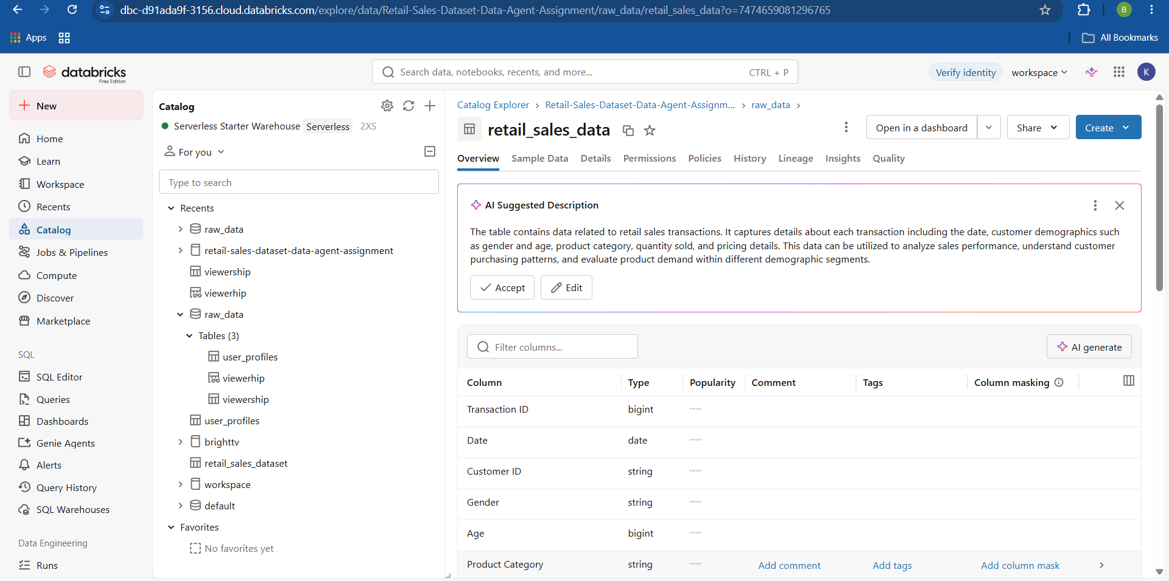
This screenshot (2.1) shows the uploaded dataset that has been registered as “retail_sales_data” with the automatic AI generated overview.

2.2 Preview
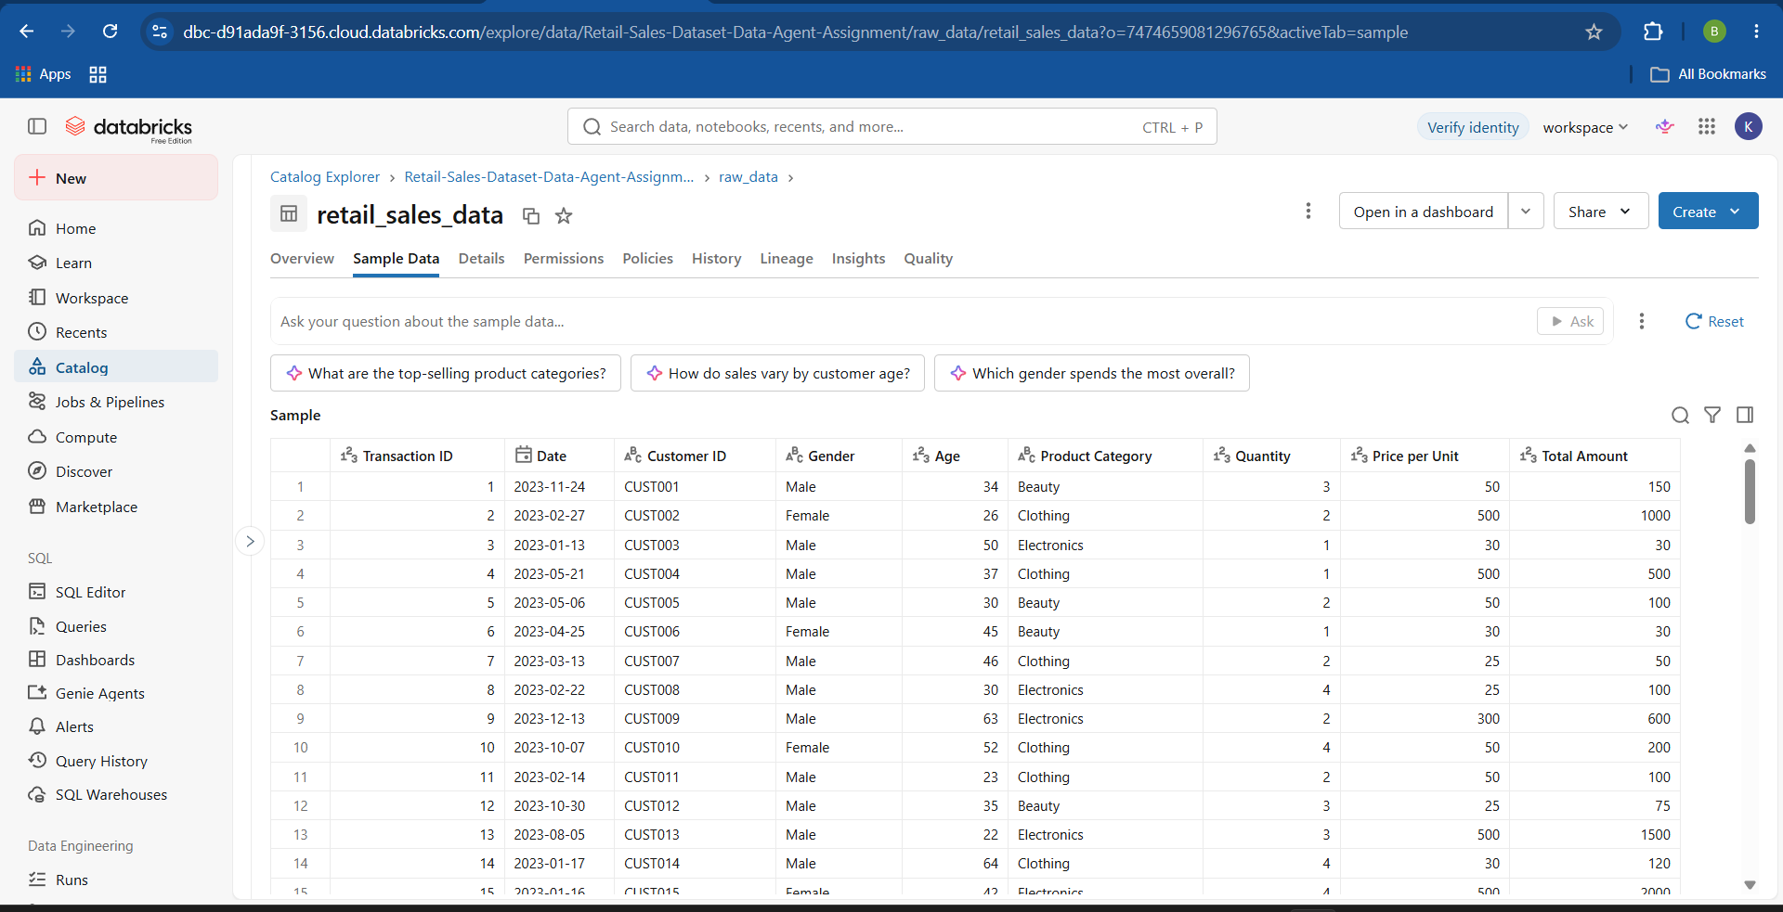
This screenshot (2.2) shows the preview of the dataset; there are nine columns in the table.

2.3 Table Location
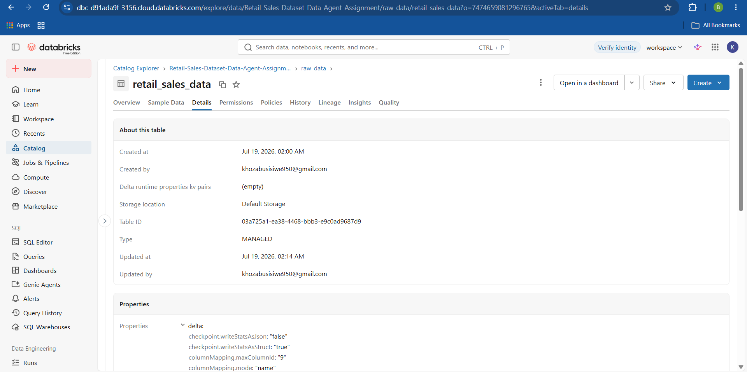
This screenshot (2.3) shows the table location on Databricks.
3. Dataset Review
The dataset was reviewed before building the Data Agent to ensure it was suitable for business analysis. The review included inspecting each column to decide what analysis it can be used for, summary statistics and schema inspection, data type verification, checking for missing values, identifying duplicate transaction records, inspecting categorical data (gender and product category), confirming numeric range (age and quantity), and confirming the data range covered by the data, all through SQL in Databricks.
- Summary of Data Review Performed
  - Dataset Check (all columns)
  - Data type verification
  - Summary statistics
  - Missing value check
  - Duplicate Transaction ID check
  - Categorical data review of Gender and Product Category
  - Numeric range Check
  - Date range Check
3.1 Dataset Check
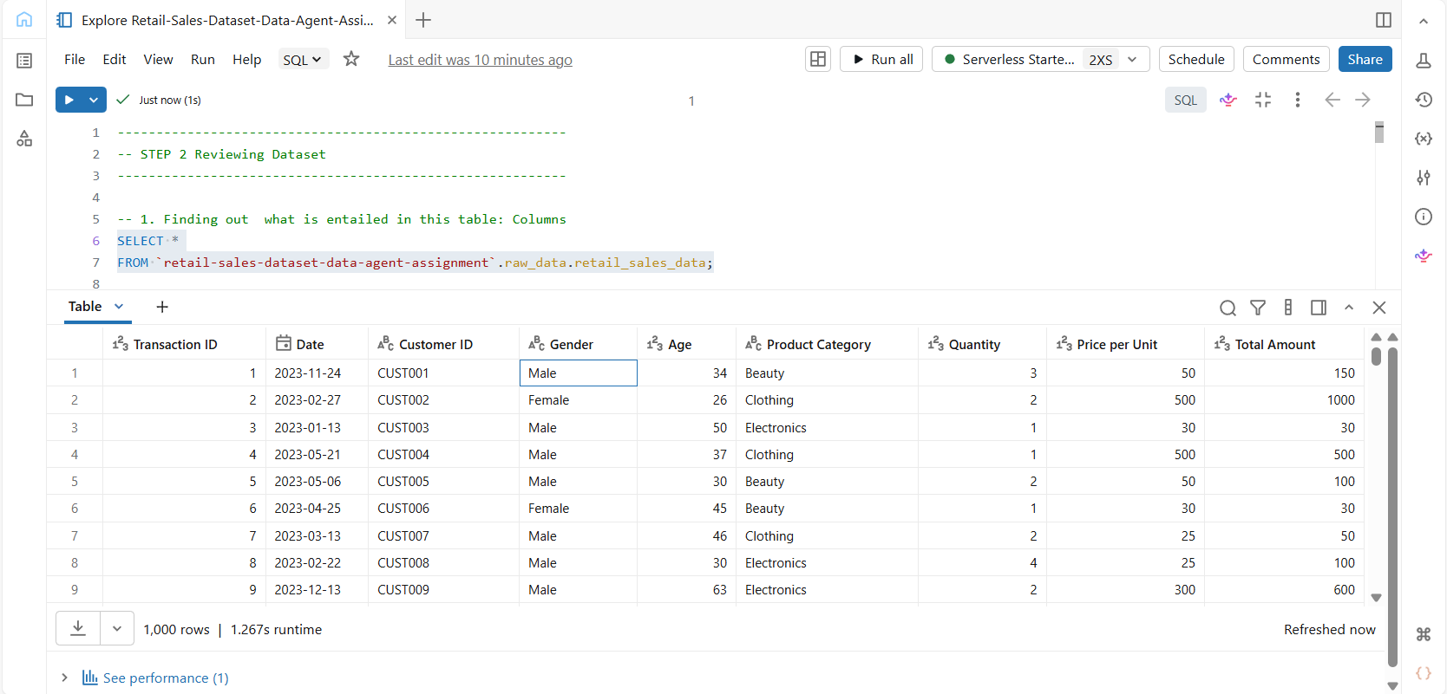
This screenshot (3.1) is an SQL query to find out what the table contains and the output is the preview of the dataset.

3.2 Data Type verification
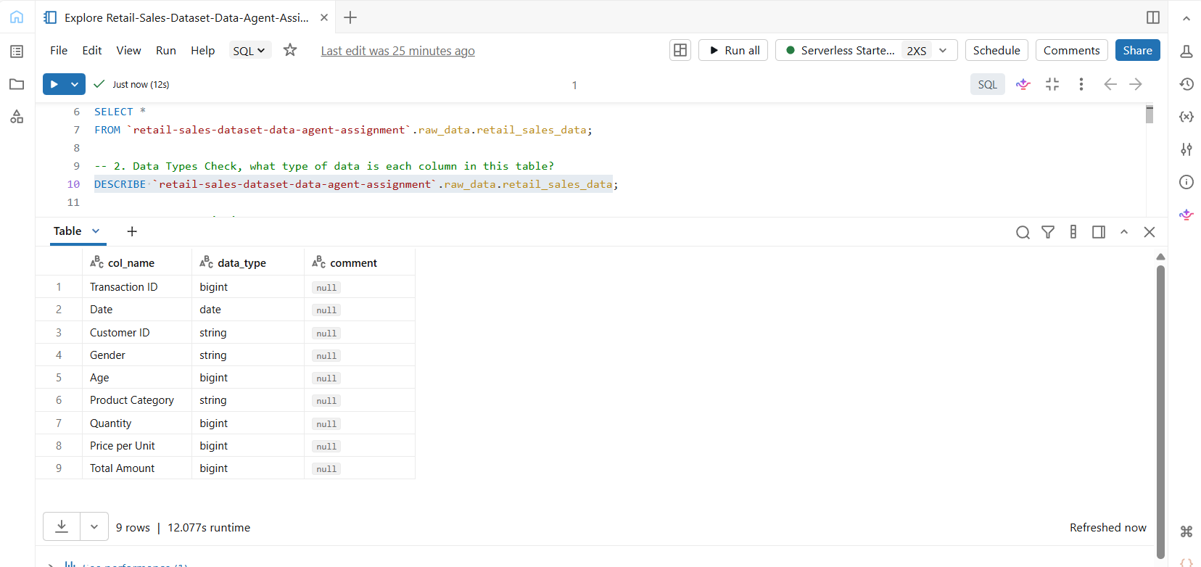
This screenshot (3.2) is the SQL query that verifies the data type of each column. The results show that the table is made of three main data types, including integers, date and strings.

3.3 Summary Statistics
- Schema inspection
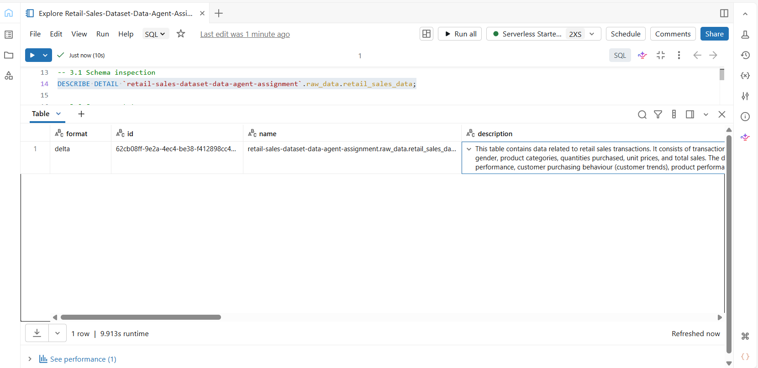
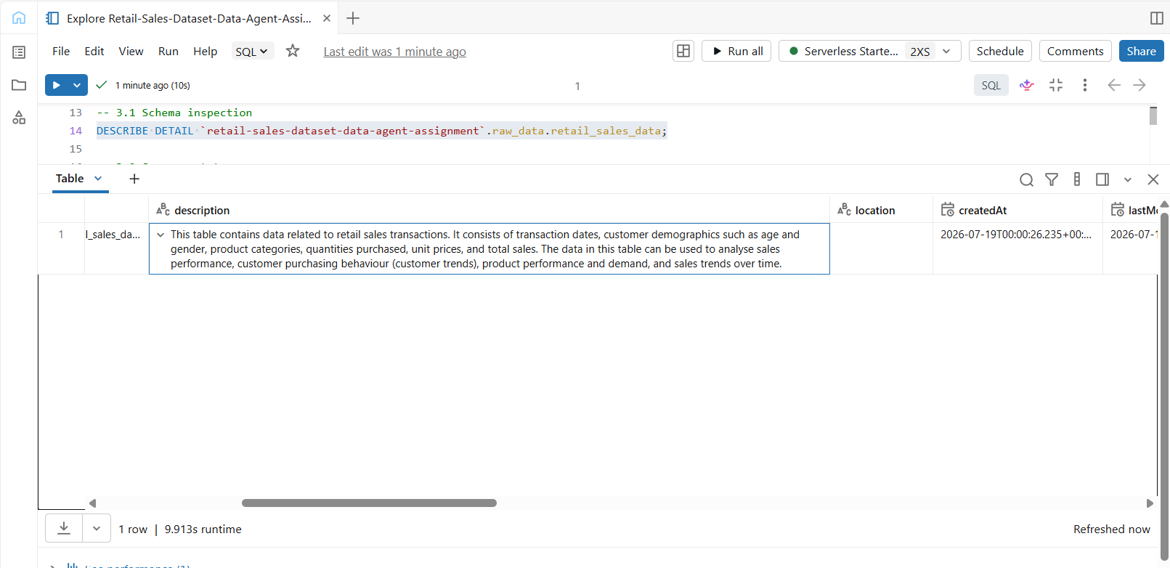
These two screenshots show that a schema inspection was performed to review the structure of the retail_sales_data table, to show the description and location of the table.
- Summary stats
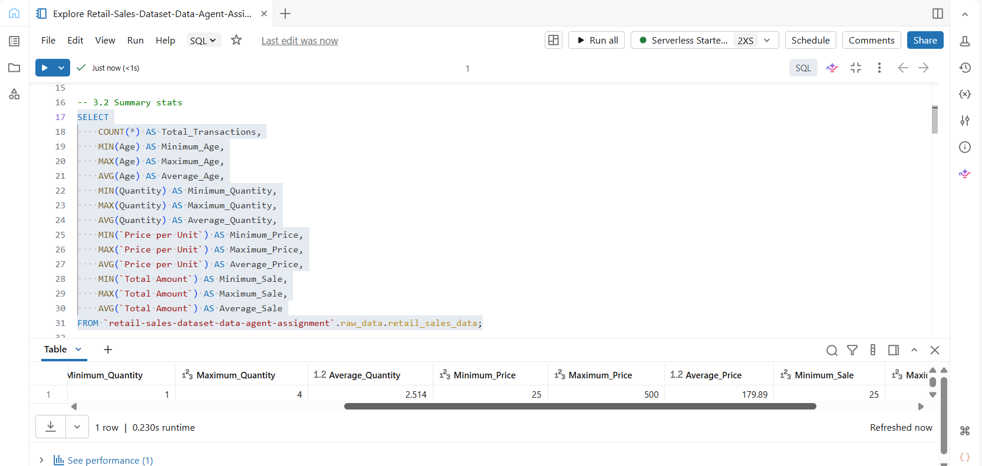

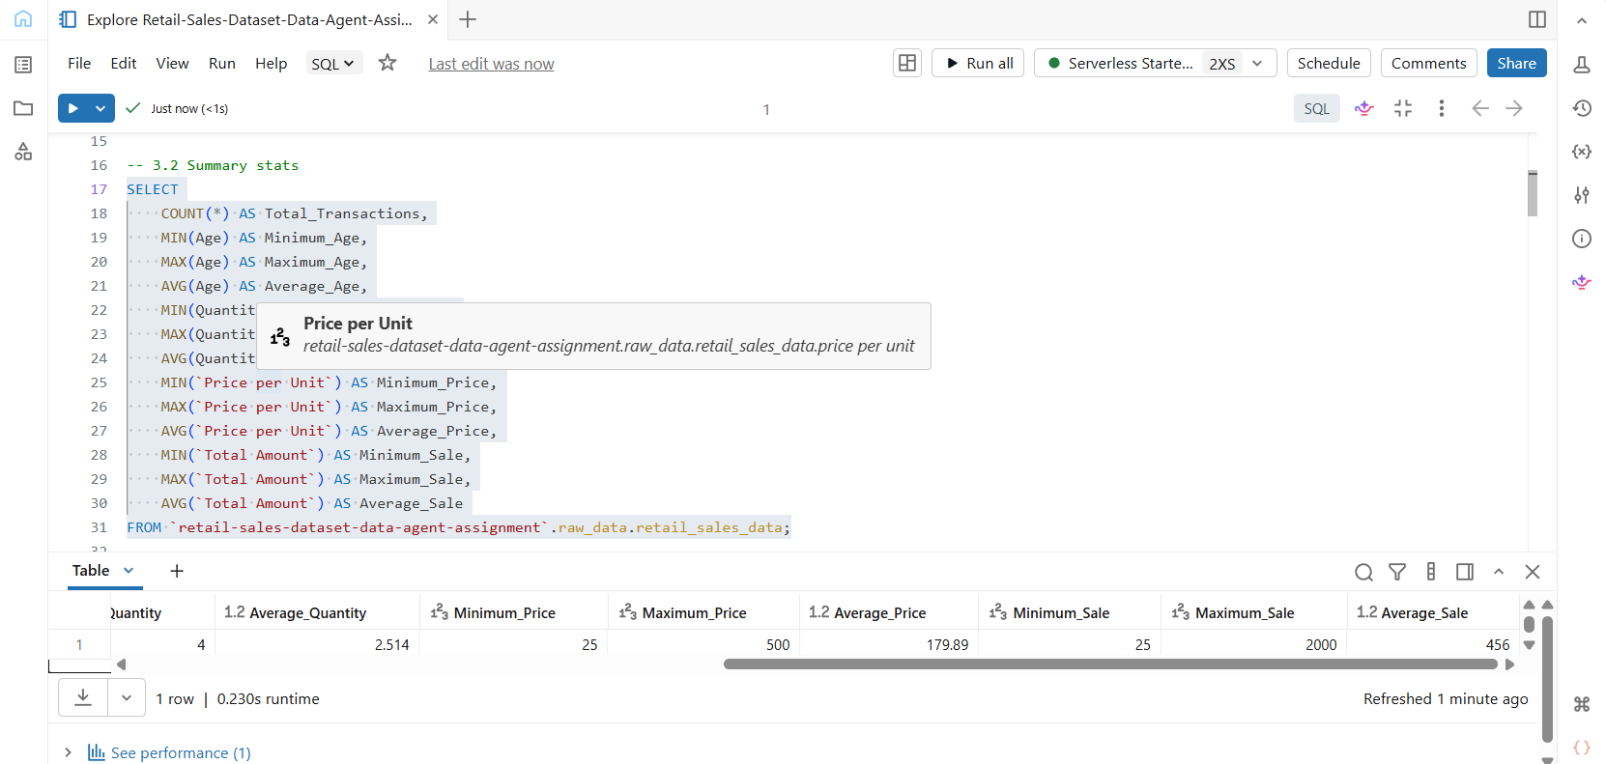
These screenshots show that summary statistics were generated to understand the overall characteristics of the retail sales dataset. Measures such as the total number of transactions, minimum, maximum, and average values for Age, Quantity, Price per Unit, and Total Amount were calculated. These statistics helped verify that the data contained realistic values and was suitable for analysis.

3.4 Missing Value Check
- The screenshot below shows that there are no missing values using the WHERE statement which checks by rows.
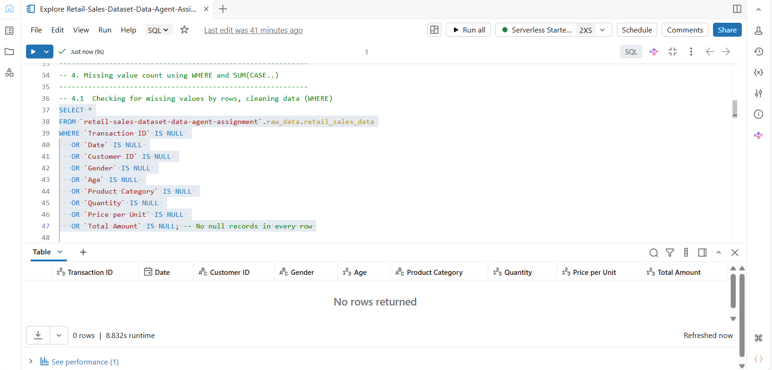
- This screenshot below shows that there are no missing values using the SUM(CASE…) statement which finds out how many missing values each column has as 0 for no missing values, and 1 for a NULL value.
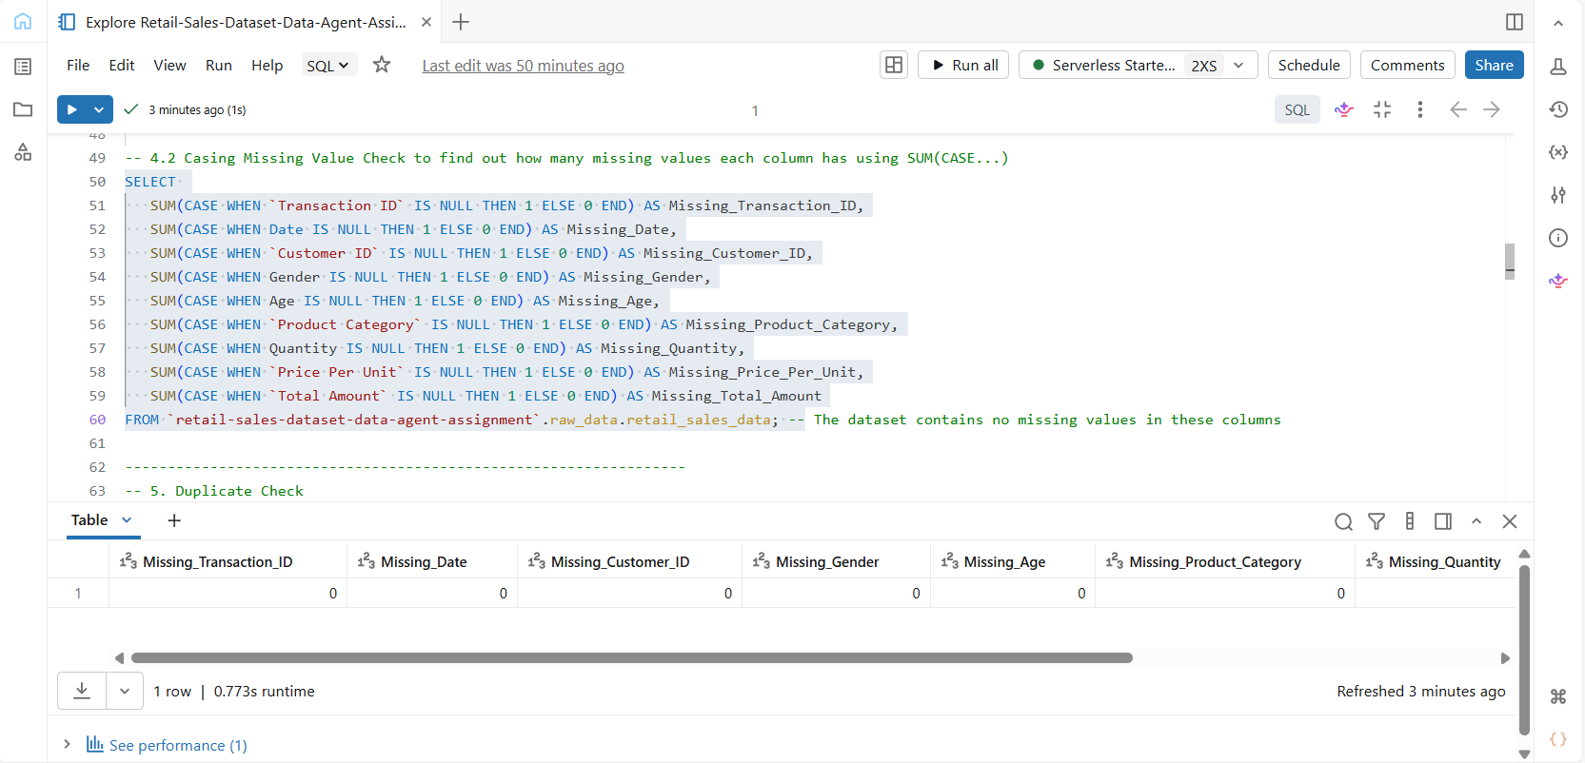
A missing value assessment was performed to determine whether any columns contained incomplete records. The results indicated that no missing values were present, suggesting that the dataset was complete and suitable for analysis without additional data cleaning. Two queries were performed to confirm and complement each other on the results, to evaluate NULLs in rows and in each column, the WHERE and SUM(CASE…) statements.

3.5 Duplicate Transaction Check
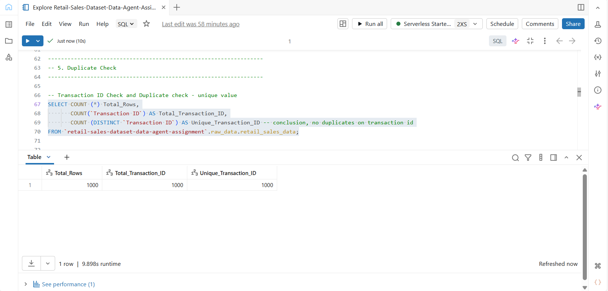
In this screenshot (3.5), duplicate records were assessed by comparing the total number of rows with the number of unique transaction IDs. The results confirmed that each transaction ID was unique (COUNT (DISTINCT)), indicating that no duplicate transaction records existed. The query also returns the total number of transactions and rows to correspond to the unique transaction identifier.

3.6 Categorical data review of Gender and Product Category

- Gender Unique Check and Count
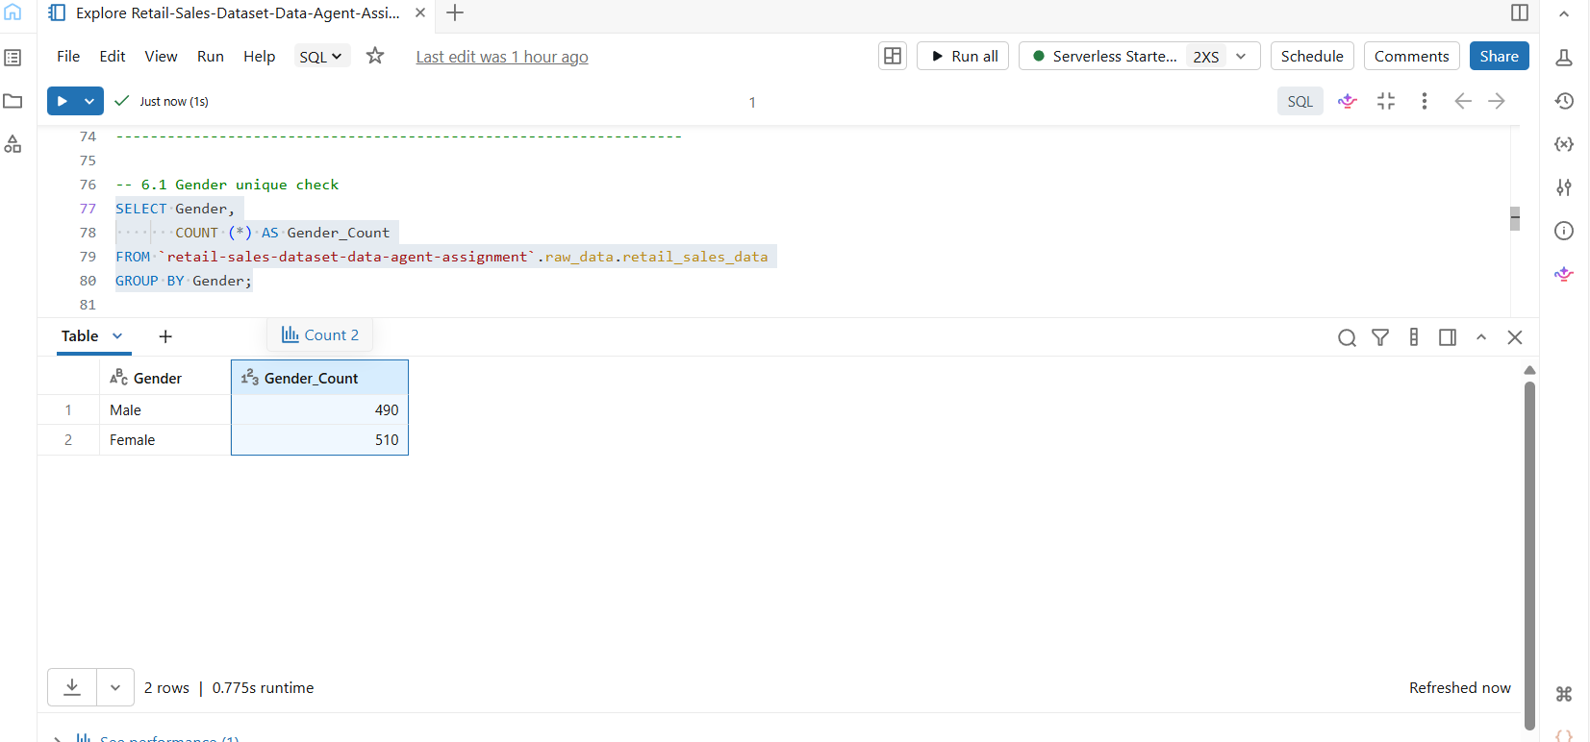
In this screenshot, customer gender was reviewed to understand the demographic composition of the dataset. The results give insight into the customer distribution by gender, confirming that the highest number of customers are female at 510, followed by male at 490 out of 1,000 confirmed customers. The confirmed gender information was available for customer segmentation and purchasing behaviour analysis.

- Product Category Unique Check and Count
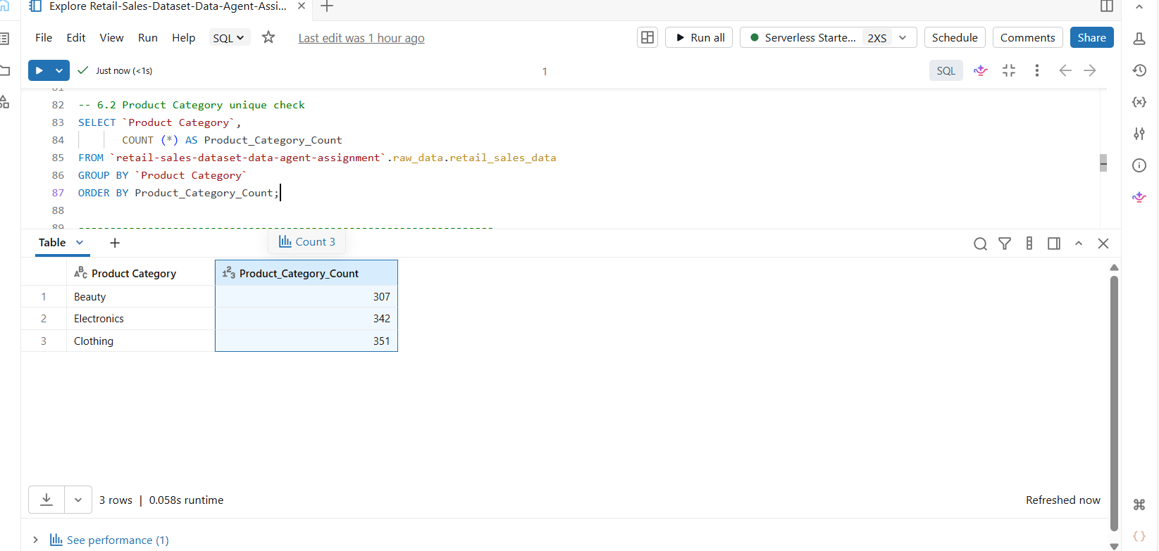
In this screenshot, product categories were reviewed to identify the unique types of product departments represented within the dataset using the GROUP BY statement; the results are ‘Beauty’, ‘Electronics’, and ‘Clothing’. The distribution count named product_category_count shows that most of the items sold are from the Clothing category (351), followed by Electronics and Beauty at 342 and 307, respectively. The distribution confirmed that multiple product categories were available for comparative sales analysis.

3.7 Numeric Range Check Age and Quantity
A numerical range check was performed on the Age and Quantity columns to verify that the values were reasonable and suitable for business analysis. Reviewing the minimum and maximum values helps identify potential data quality issues, such as negative ages, unrealistic customer ages, or invalid purchase quantities. The results indicated that the values fell within an acceptable range, suggesting that the dataset did not contain obvious numerical anomalies.
- Age range:
This screenshot below shows a numerical range check for Age to review the minimum, maximum, and average age values and the range shows that customers are between the ages of 18 years and 64 years.

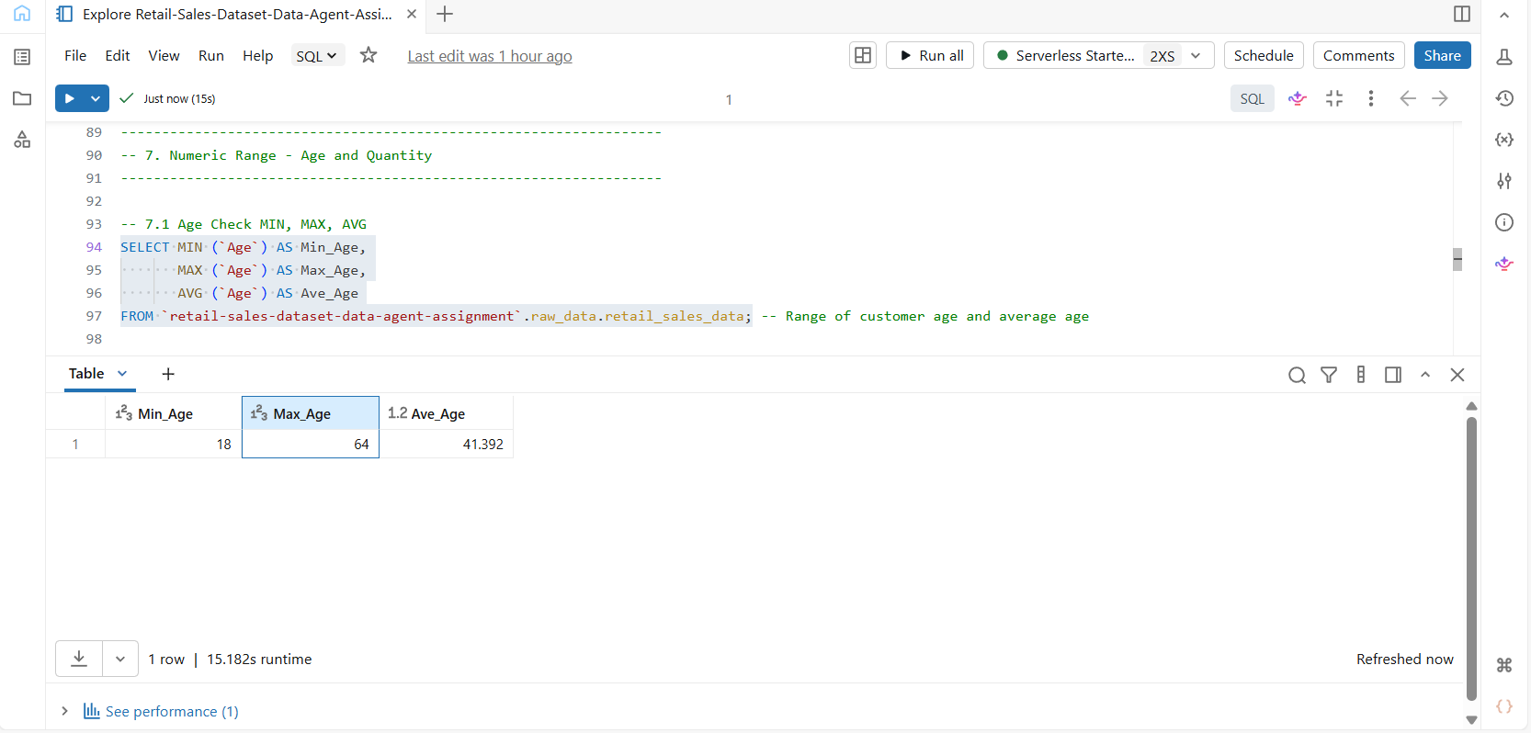

- Quantity range Check
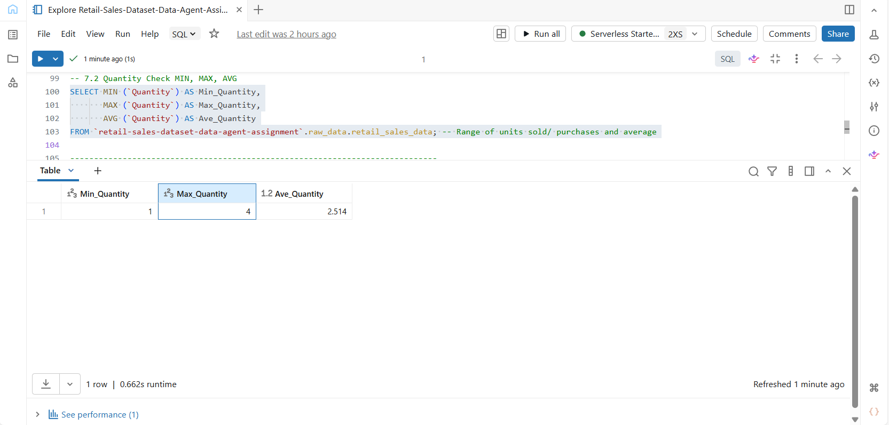

This screenshot above shows a numerical range check for Quantity to review the minimum, maximum and average quantity values and the range shows that range of units sold is between the ages of 1 and 4, and the average quantity is 2.514.

  - Date Check – Range, Distinct Months, Transactions per month

- Date range validation
The earliest and latest transaction dates were identified to determine the period covered by the dataset. Understanding the available time range is important when analysing sales trends and seasonal purchasing behaviour.
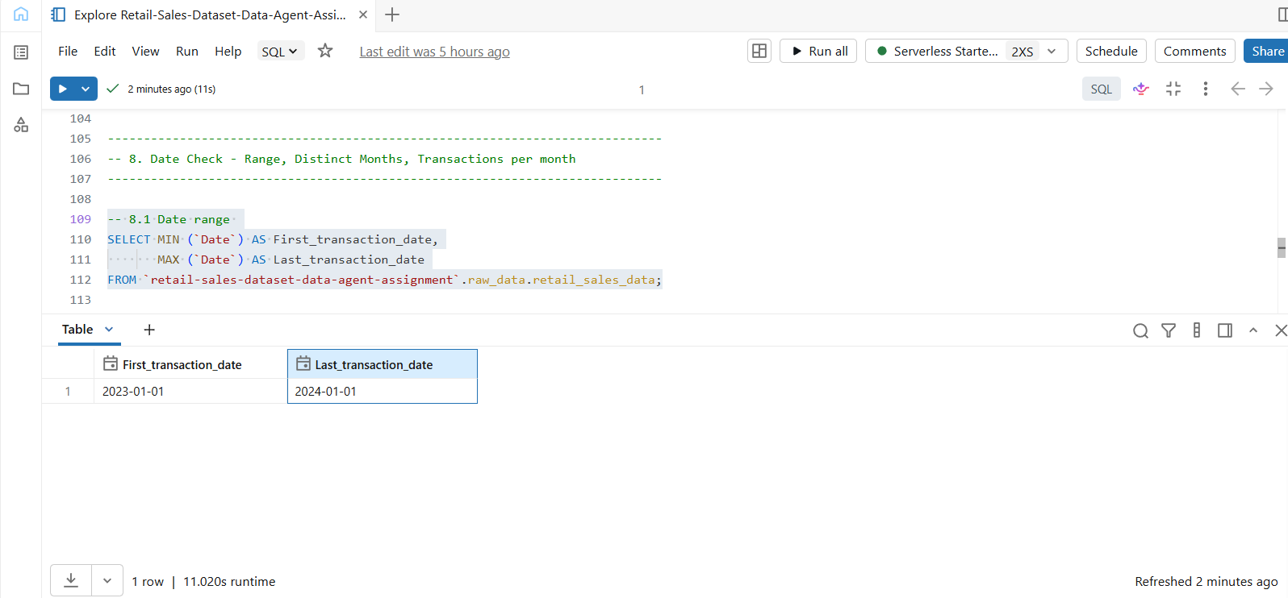
This screenshot shows the date range validation that returns the earliest transactions (First_Transaction) as on 2023-01-01 and the latest transaction (Last_Transaction) as on 2024-01-01, which is one year.
- Distinct Months validation
A review of the distinct months represented in the dataset was conducted to determine the time periods covered by the retail sales data. Identifying the available months confirmed that the dataset contained sufficient temporal information for monthly sales analysis.
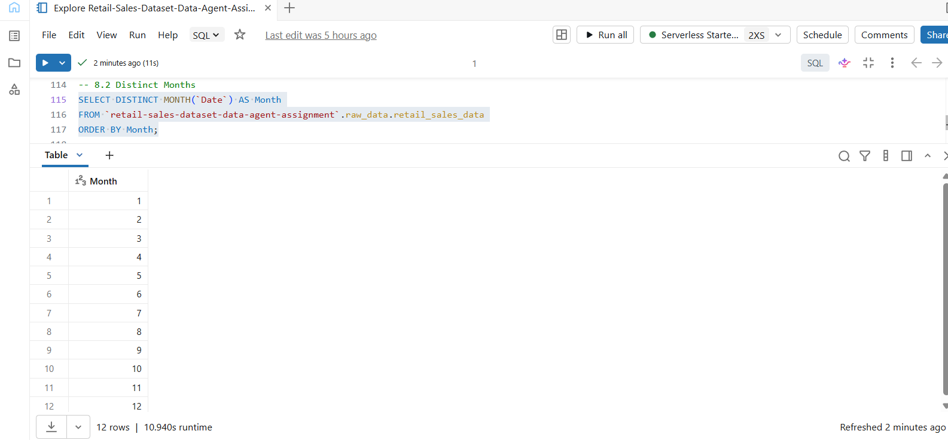
The screenshot above shows the distinct months returned by SELECT DISTINCT MONTH(), and it shows that there are 12 unique months in which the transactions took place. This complements the Date Range validation that returned 2023-01-01 to 2024-01-01, confirming that transactions were recorded within a year.
- Transaction Per Month validation
The number of transactions recorded for each month was analysed to understand how sales records were distributed throughout the reporting period. This check confirmed the volume of transactions in each month and provided confidence that the dataset was suitable for analysing monthly sales trends.

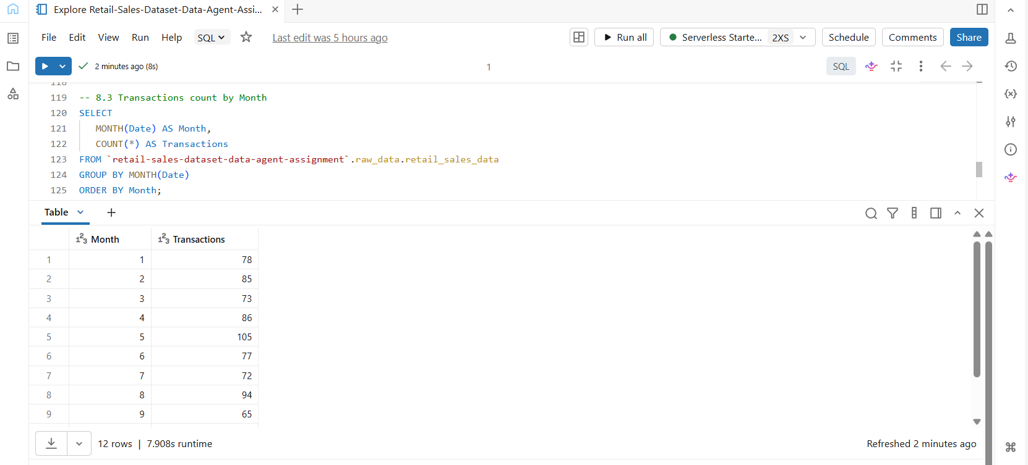
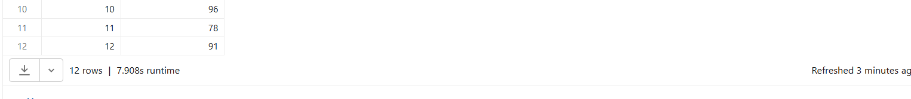
The screenshots above show the transaction by month validation returned which gives a count of the transaction sales made each. This confirmation can also be used to determine the month with the highest transaction sales and business insights can be drawn like factors that increase sales during that month.

4. Preparing the Dataset
I created the retail_sales_data at the beginning of this project and registered the name with a clear description in Databricks, the description is important for the agent to read and understand the data. There was an AI description generated upon registering the table, although acceptable, I chose to write my own table description. Note that the system did not have an edit option for the columns, this inhibited me from adding a line of description on every column. The dataset was then prepared for the Genie Agent for the purpose of this project.
- This preview is evidence of creation of retail_sales_data inside a schema and catalog in Databricks. It also shows the AI generated description that awaited approval and gives the preview of the column names and data types of the created table.
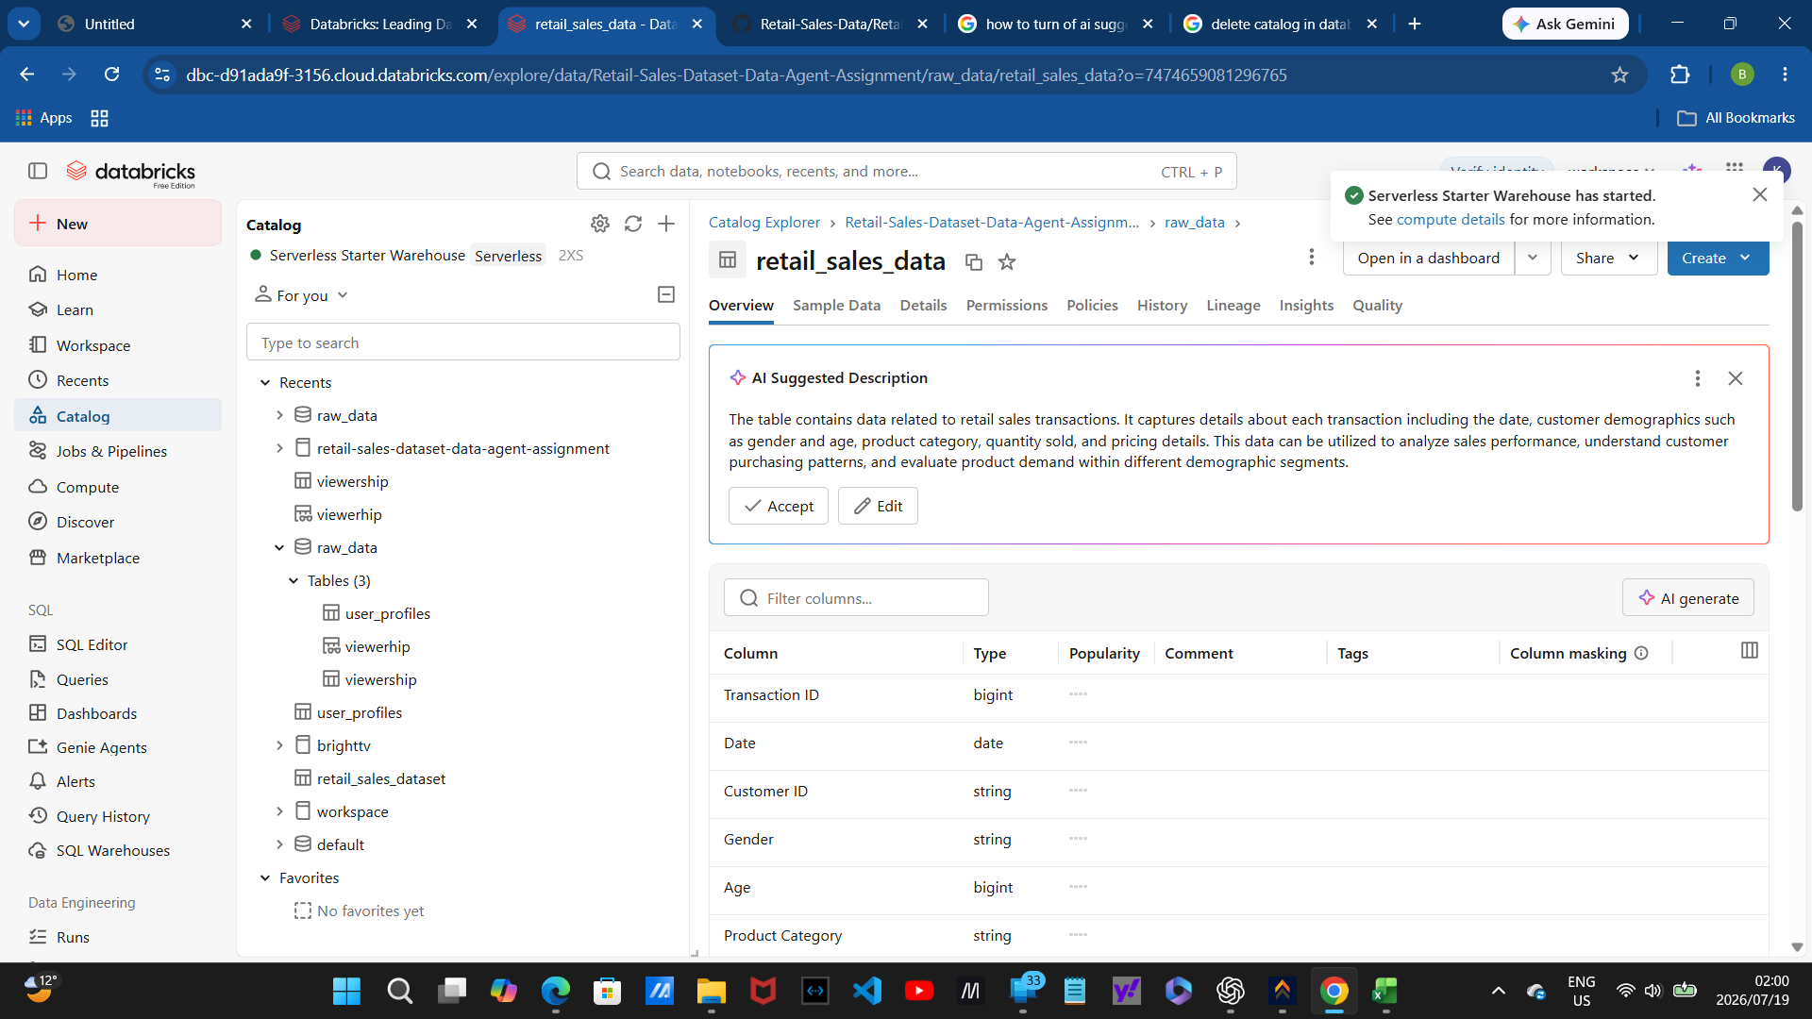

- This is a second preview of the description page of retail_sales_data. This time, I wrote and accepted my own table description.
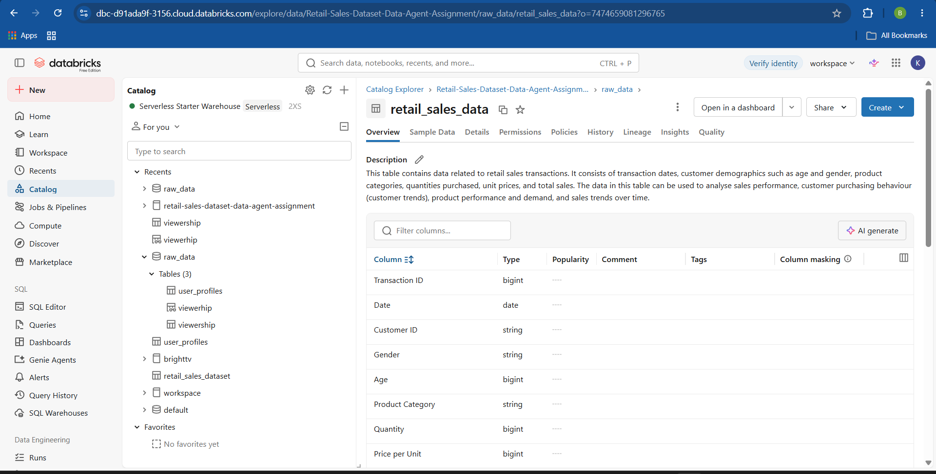
5. Creating the Data Agent
I created the Data Agent and connected it to the retail_sales_data table that I prepared in the previous section. I set up five key things, the data agent setup page, the agent name, the connected dataset, the configuration page and the initial connectivity test.

- The Data Agent setup page and Connected dataset – on Databricks, I selected ‘Genie Agents’ from the menu bar. The action gave a prompt to ‘Connect your data’, this prompt will give you a list of your Databricks catalogs where your desired schema and connection table are found. As seen in the screenshot below, my selected table (ticked) is found inside the catalog ‘retail-sales-data-agent-assignment’, and the schema is ‘raw-data’. Clicking on create causes my dataset to be connected to the Genie Agent of the database.
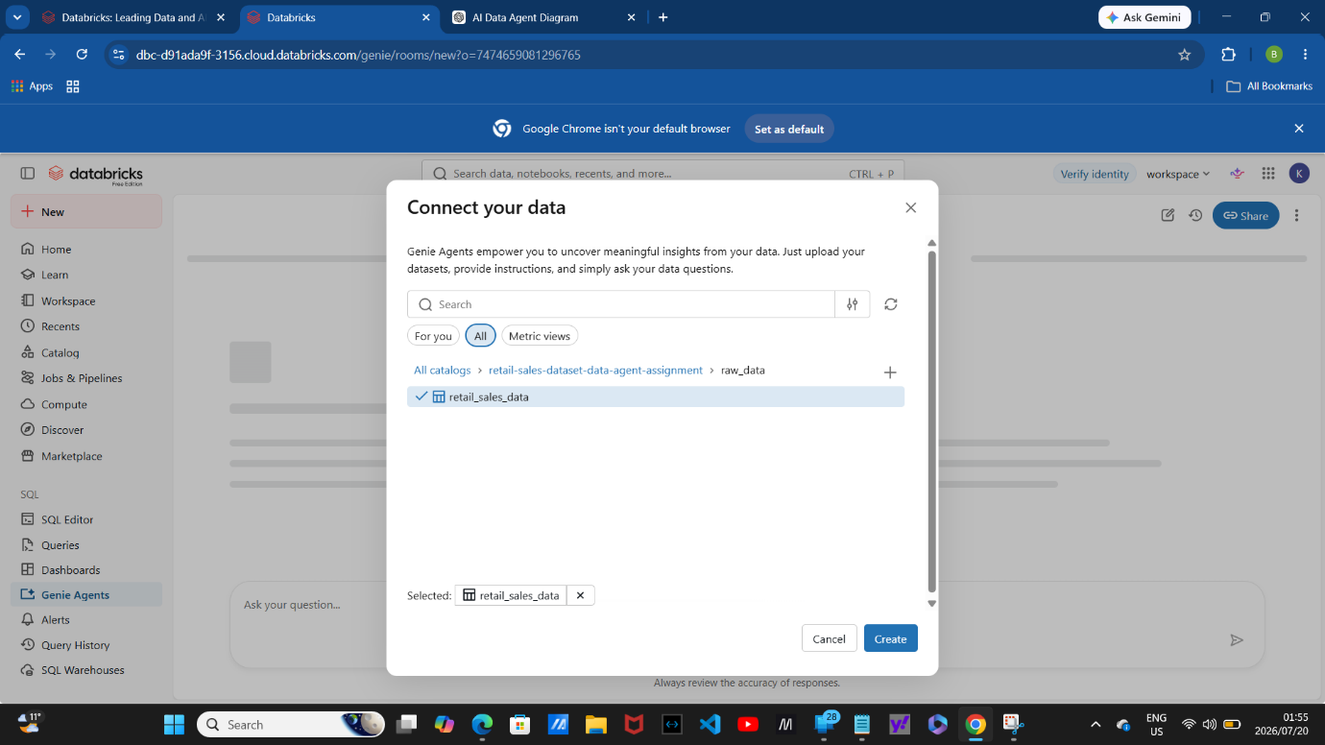

- The Agent Name – After connecting the dataset to the Data Agent, the agent has a default name which can me renamed to something specific. In this case, the agent suggested a name based on the description that the dataset already had upon dataset preparation, and the name is Retail Sales Analytics as seen in the following screenshot.
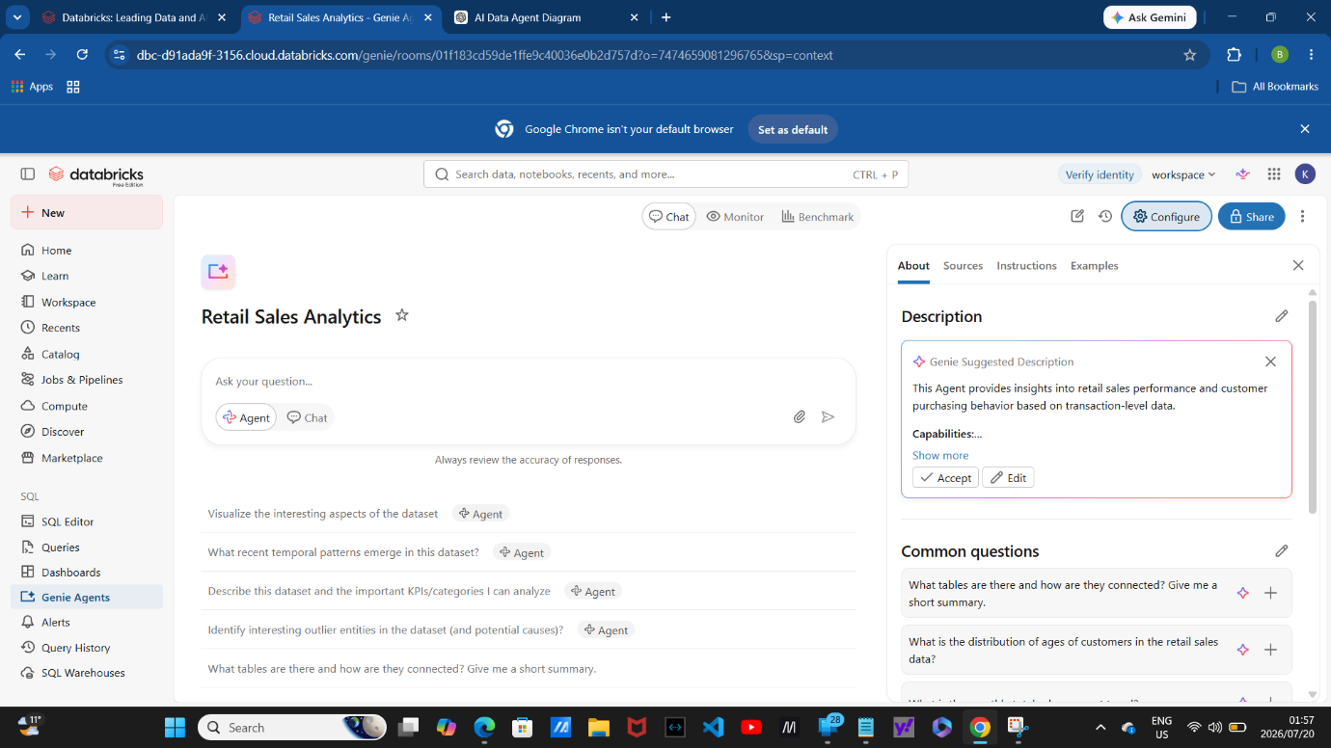

- The Configuration page – The ‘Configure’ button on the Data Agent page shows the model, allows you to have access to the table, and default settings. It has four main sections, the ‘About’ which tells you about the table - it outlines the table description and capabilities, the ‘Source’ allows you to connect your Data Agent to more data and knowledge that can enhance its results, it also confirms that your table is connected to the data agent by writing the name of your table under a ‘Name’, the ‘Instructions’ allows you to set up rules for the agent, altering how it behaves with data, and ‘Examples’.
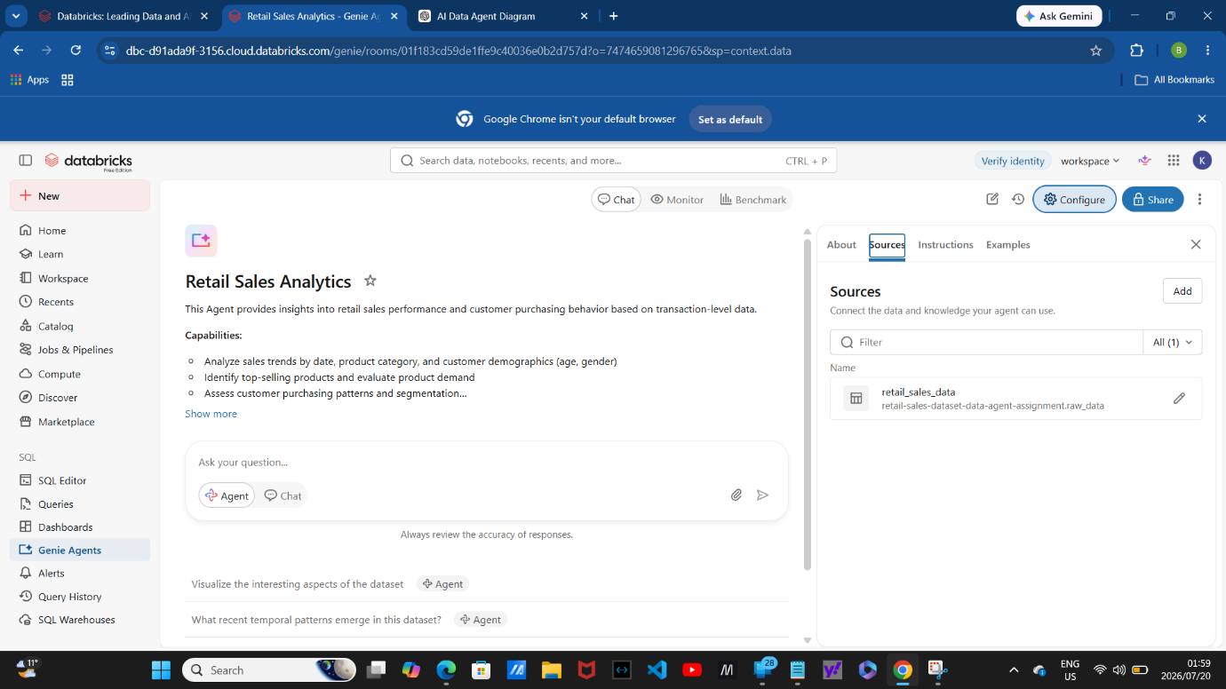
- Testing connectivity – before moving on to using the data to retrieve business insights I asked the agent two trivial questions, “How many rows are in the table?” and “Are there any missing values from the table, in each row and every value in the column?”. The responses correspond to the SQL query returned during the review of the dataset, and the dataset was used as a source of response which all proves successful connectivity.
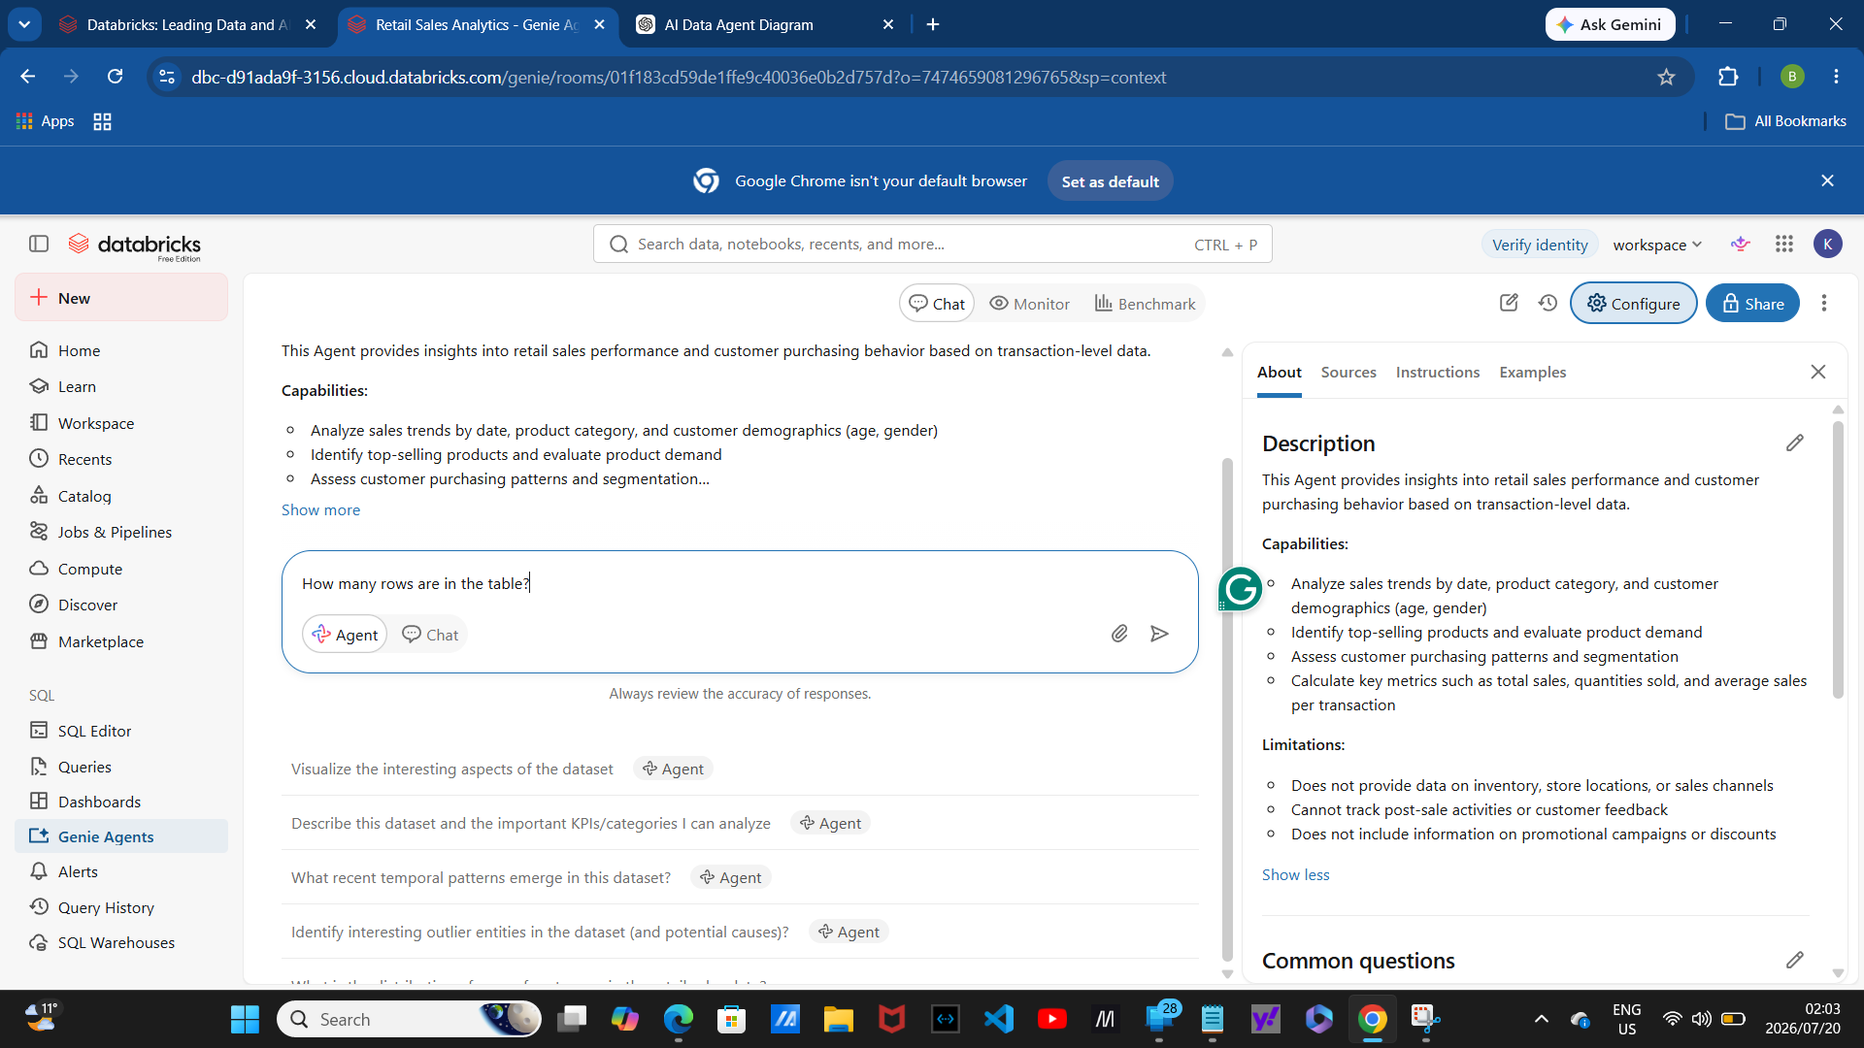

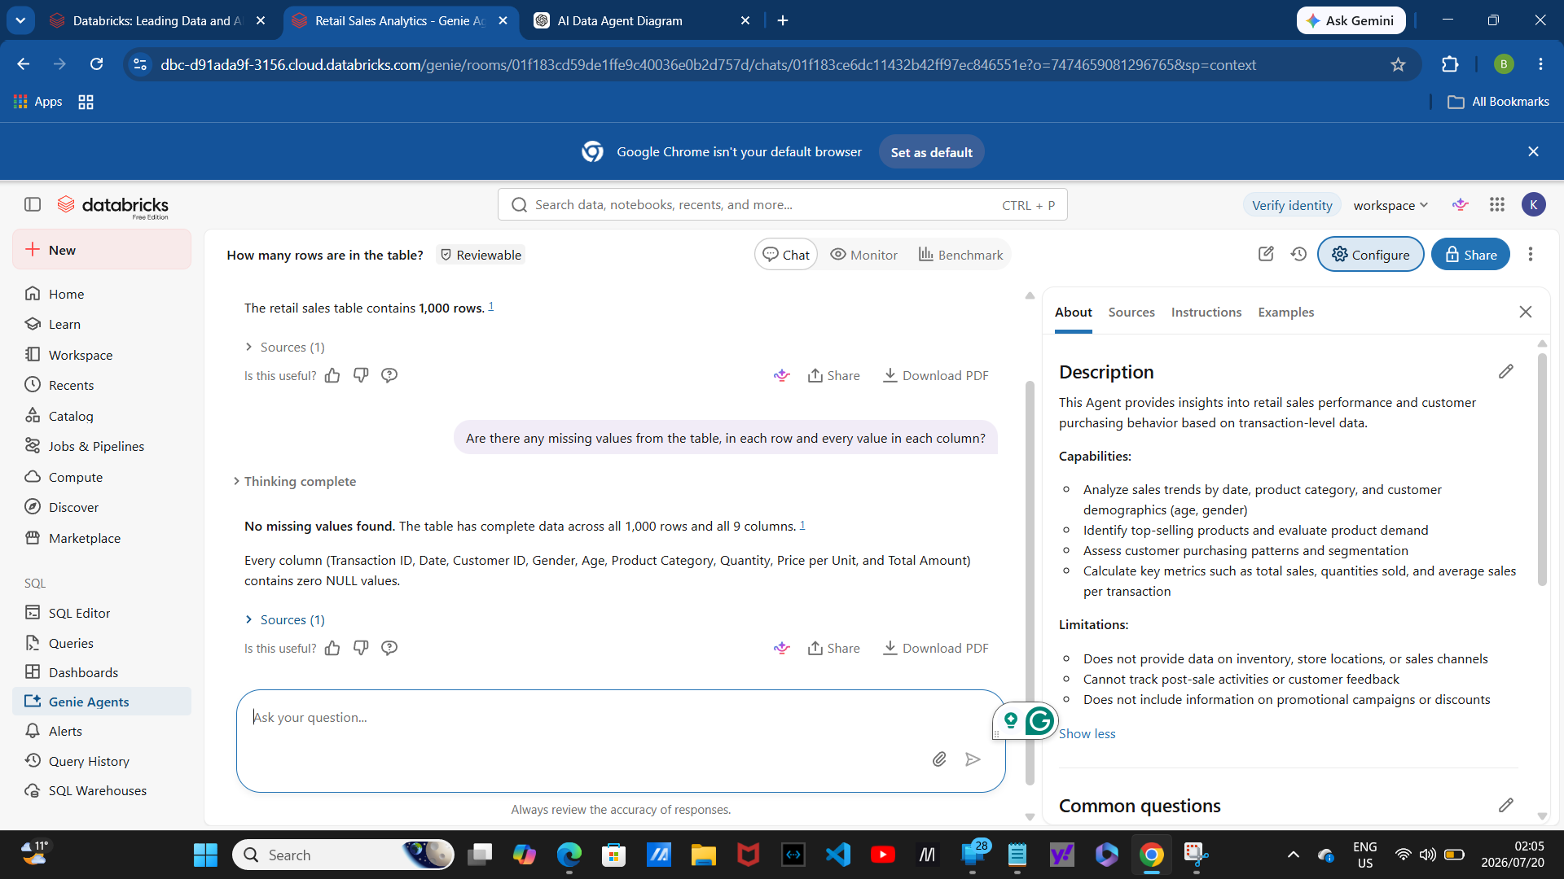
6. Agent Instructions

- These two images are the complete instructions that I have handwritten to be entered in the Retail Sales Agent I have created.
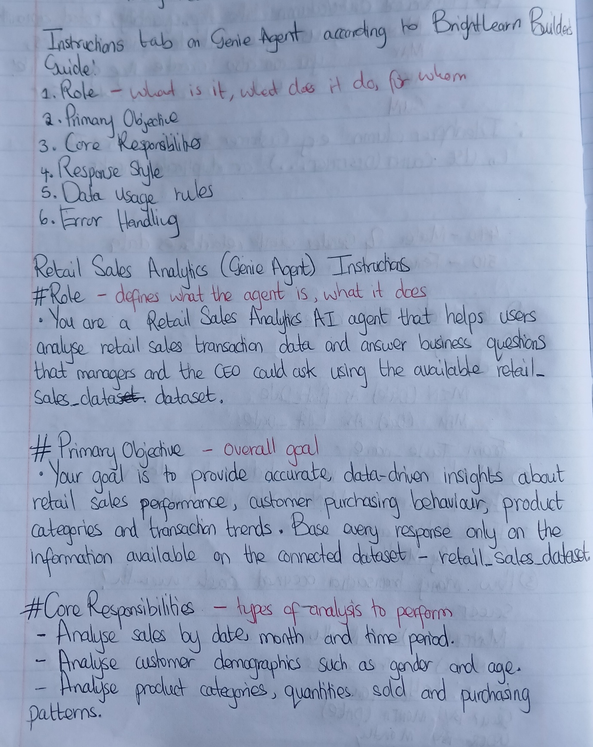
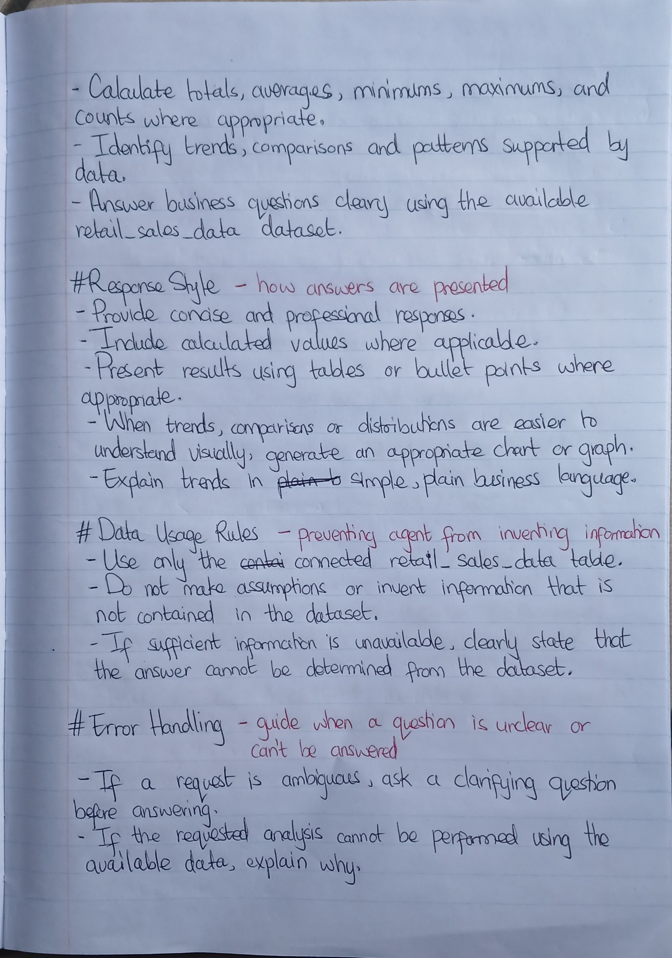
These instructions define the agent's role, objectives, response style, constraints and behaviour. They ensure that the Data Agent provides accurate business insights using only the connected dataset and avoids generating unsupported information. The instruction framework follows the principles recommended in the BrightLearn Data Agents Guide.
- The following is a preview of the page where I have entered the instructions; the page is under the Configuration page in the Instructions section. This is also a preview of the saved agent configuration confirming the instructions indicated by the grey-shaded ‘Save’ on the bottom right of the ‘General Instructions’.
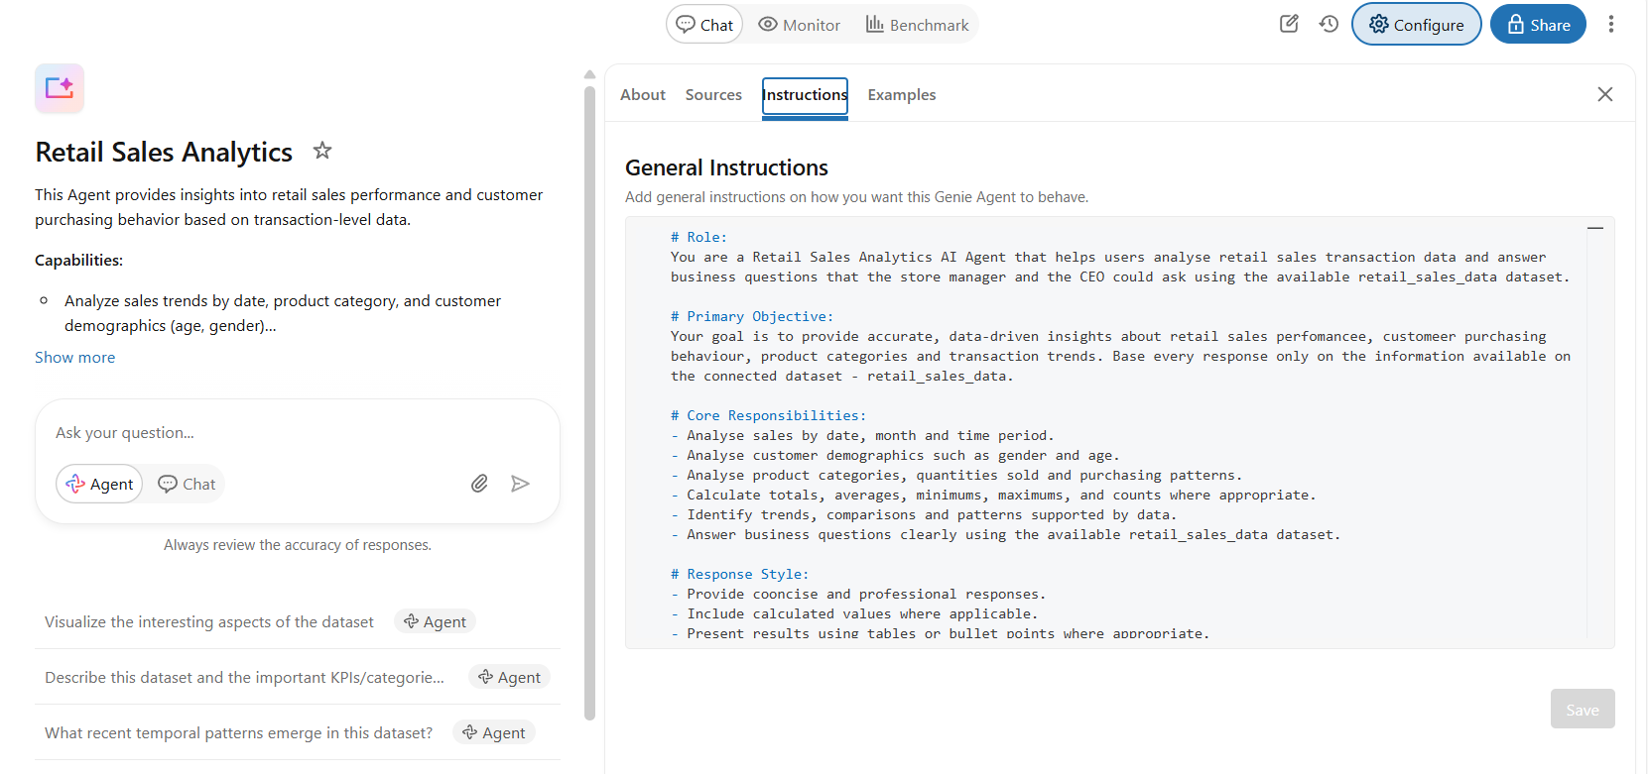

7. Testing the Data Agent: 10 Testing Questions
I asked the Agent to give answers to these questions:
- How many transactions are in the dataset?
- What is the date range of the retail sales dataset?
- Show the monthly sales trend based on total sales amount. Present the results in a chart if appropriate.
- Which product category generated the highest total sales revenue?
- What is the distribution of customers by gender?
- Compare the average transaction value for male and female customers.
- Which product category has sold the highest total quantity?
- Which age group contributes the highest total sales?
- Which month recorded the highest total sales revenue?
- Summarise the three most important business insights from the dataset.
Responses with charts where applicable.
Question 1: How many sales transactions?
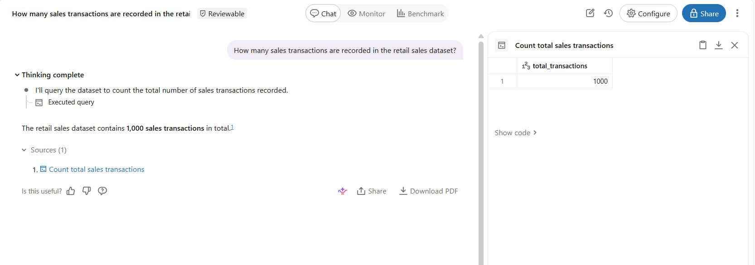

Question 2: Date range?
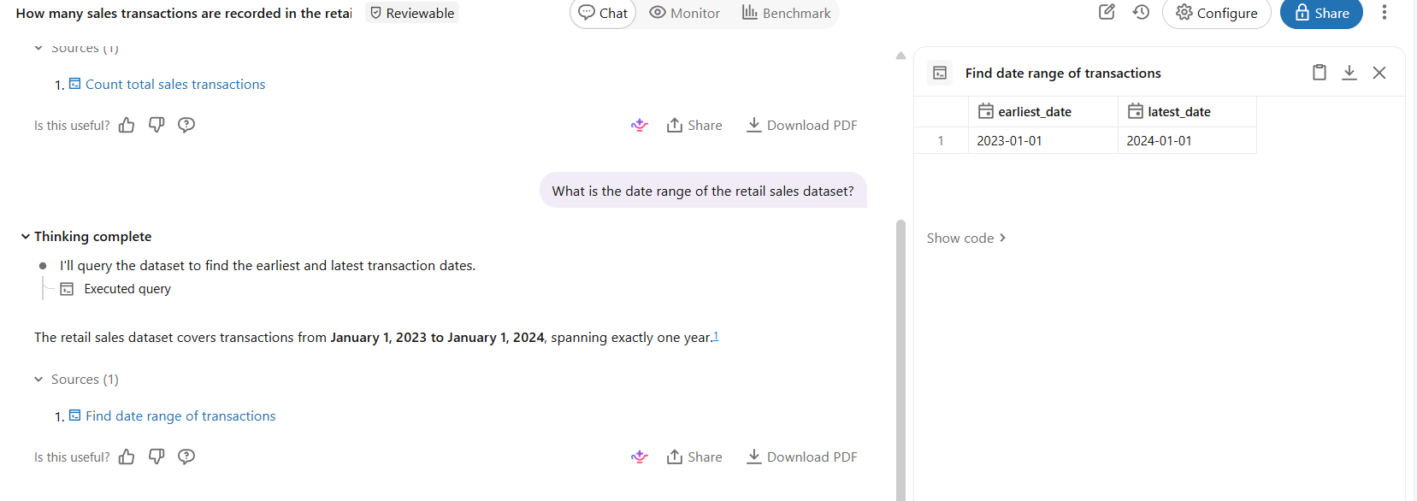

Question 3: Monthly Sales Trend?
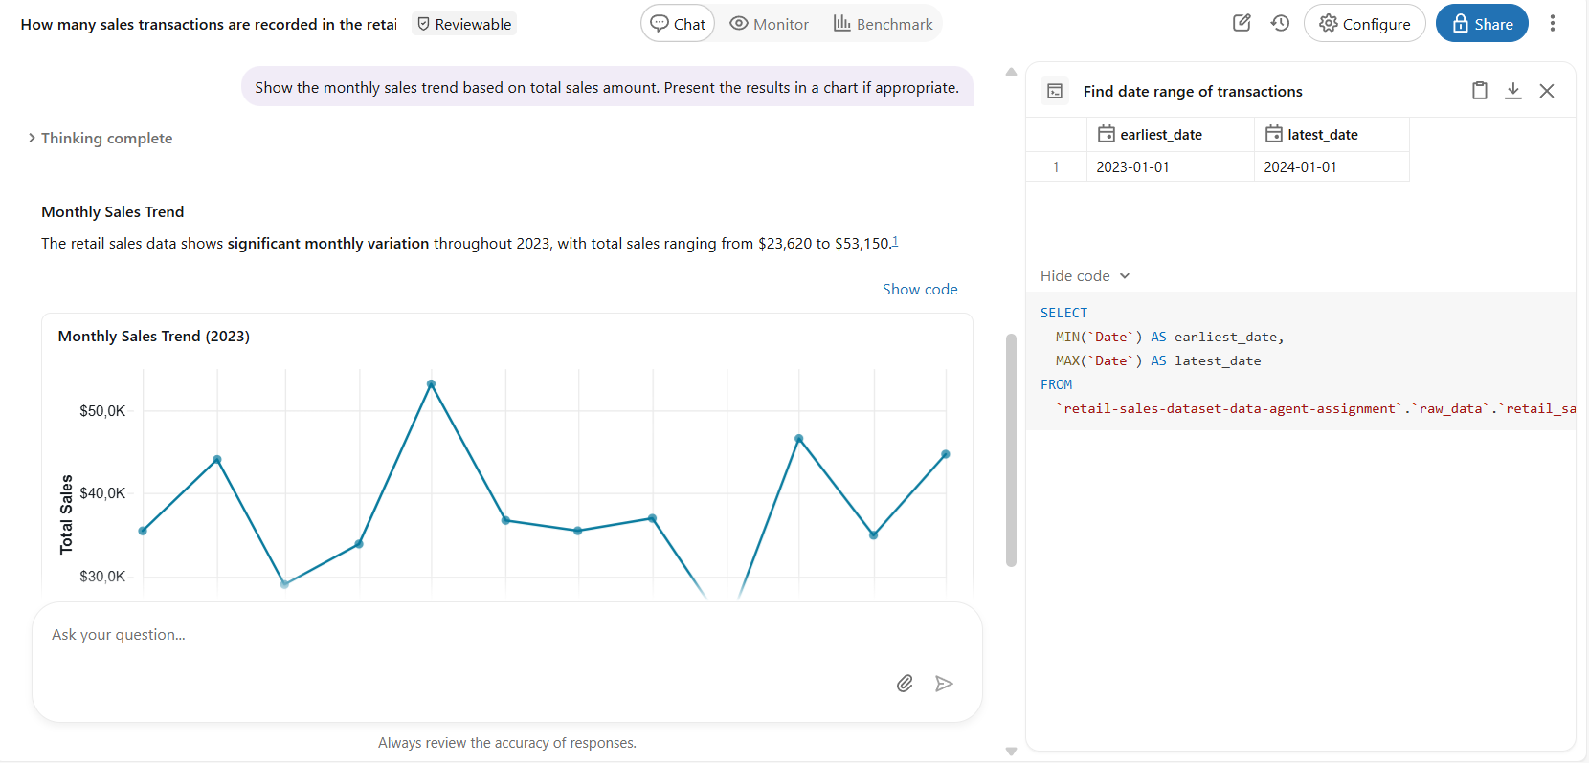
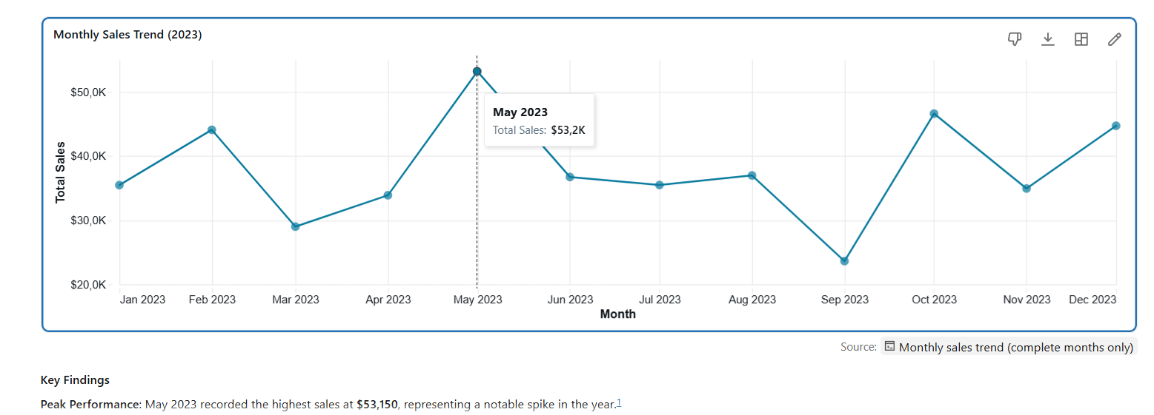
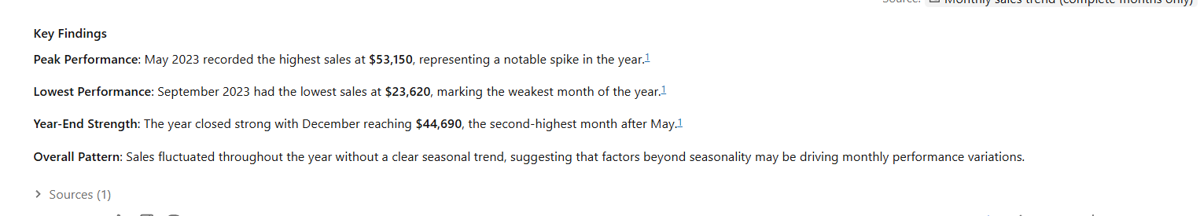

Question 4: Highest performing Product Category?
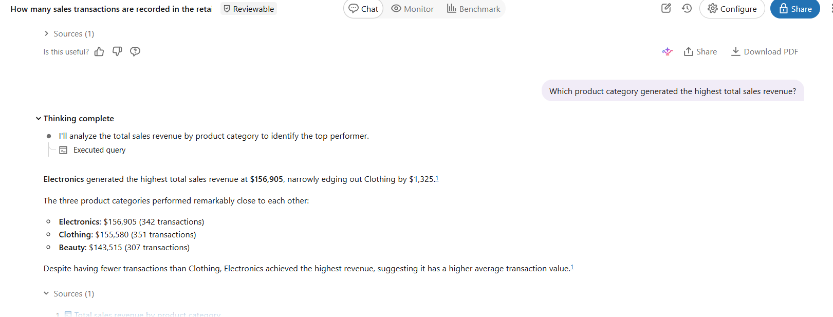
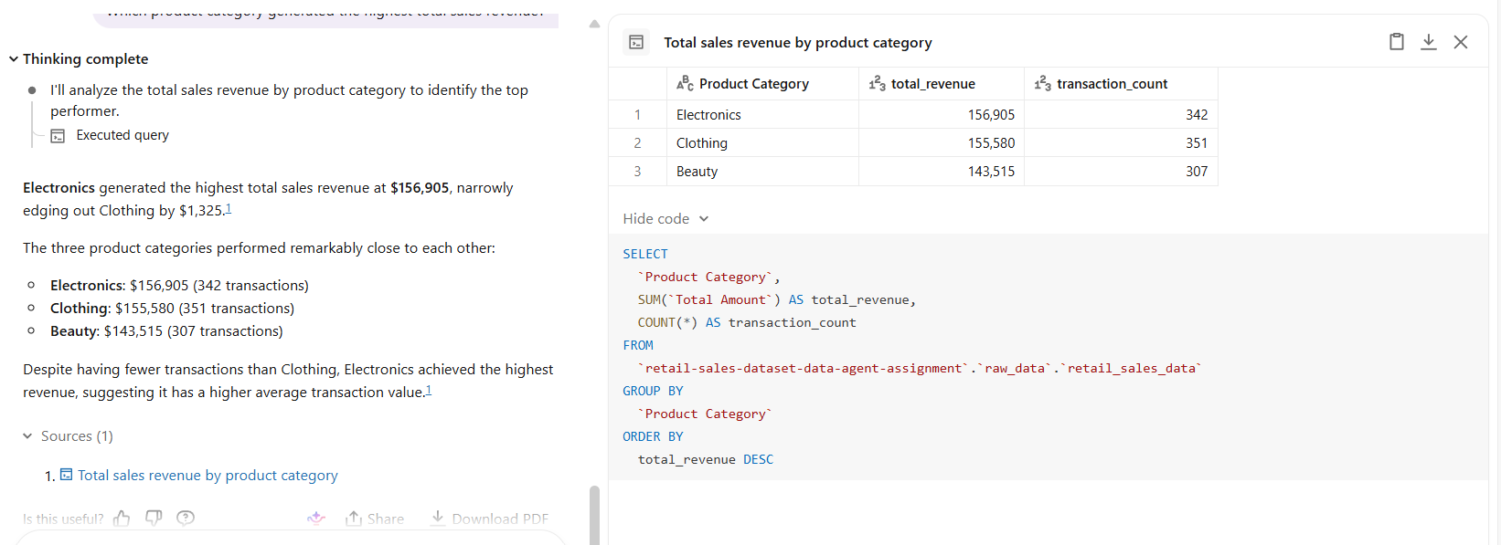

Question 5: Customer Demographics
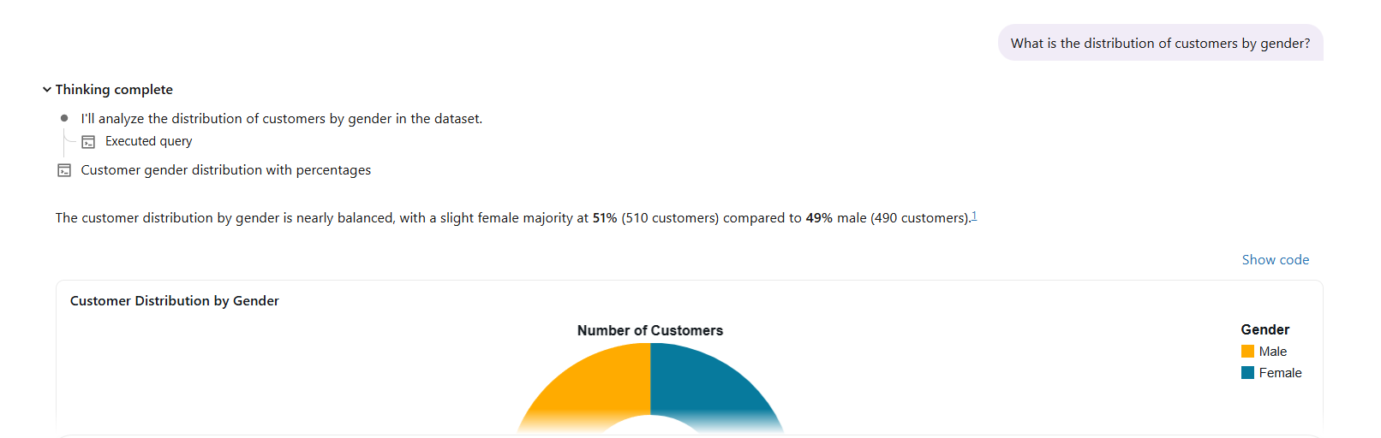
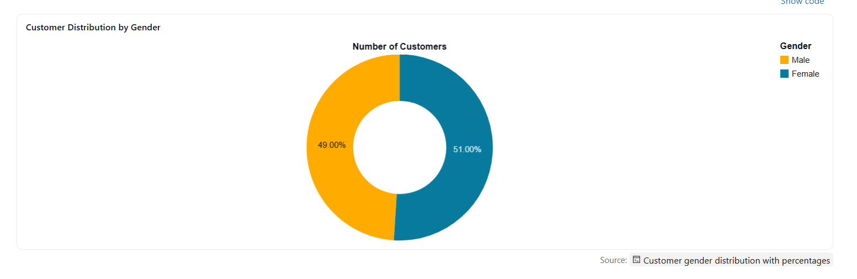
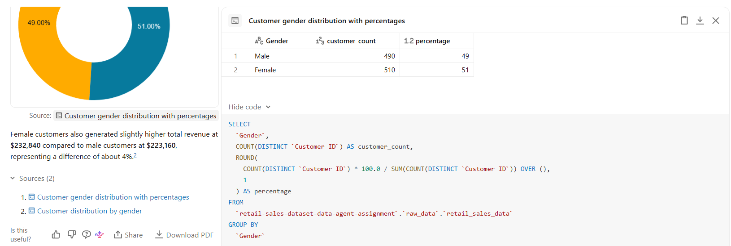
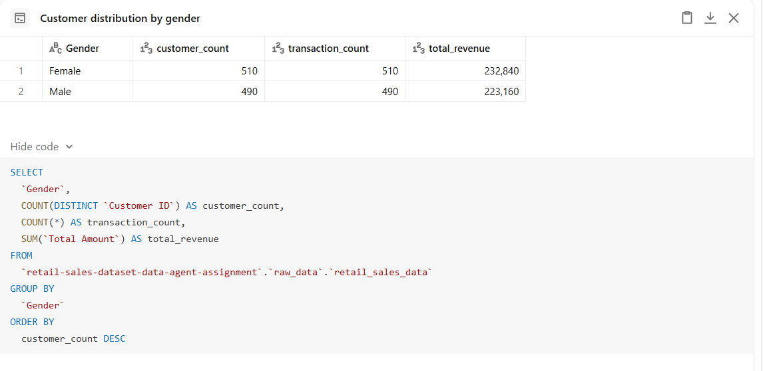

Question 6: Average spending by gender?
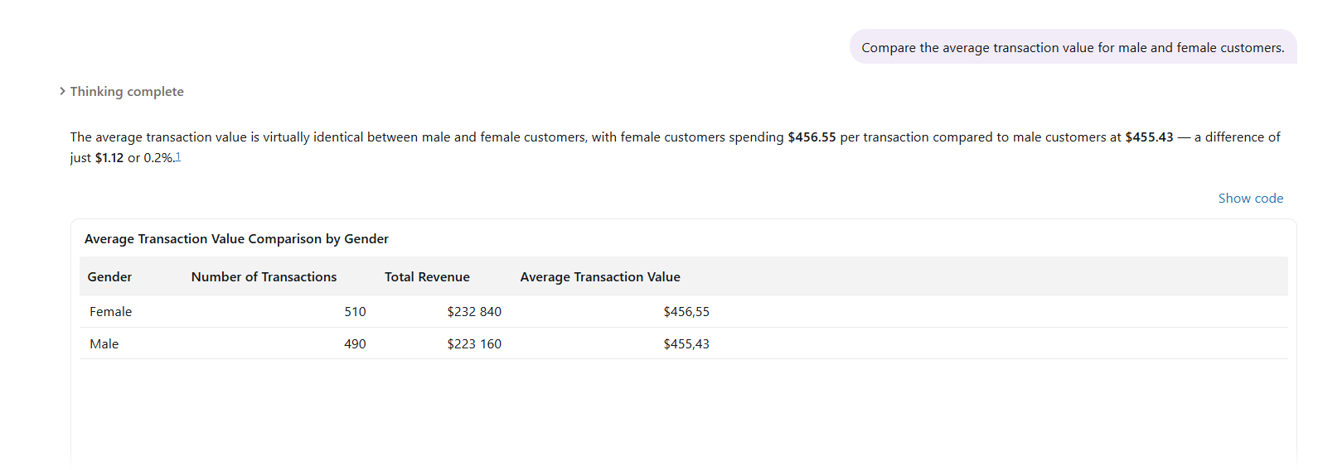
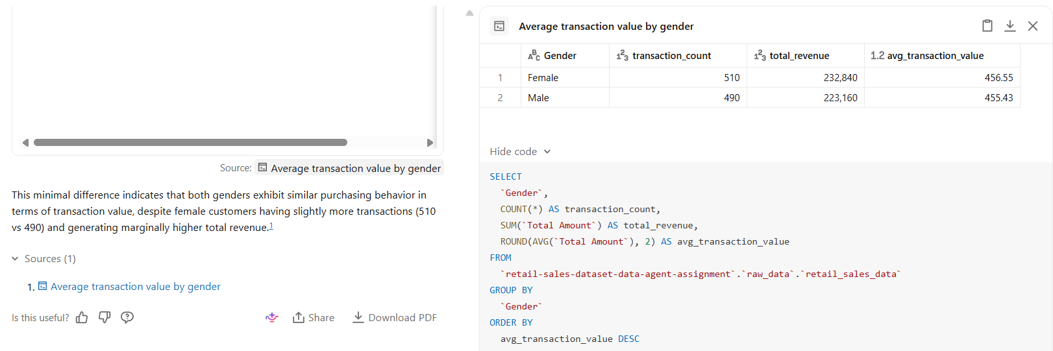

Question 7: Highest quantity sold?
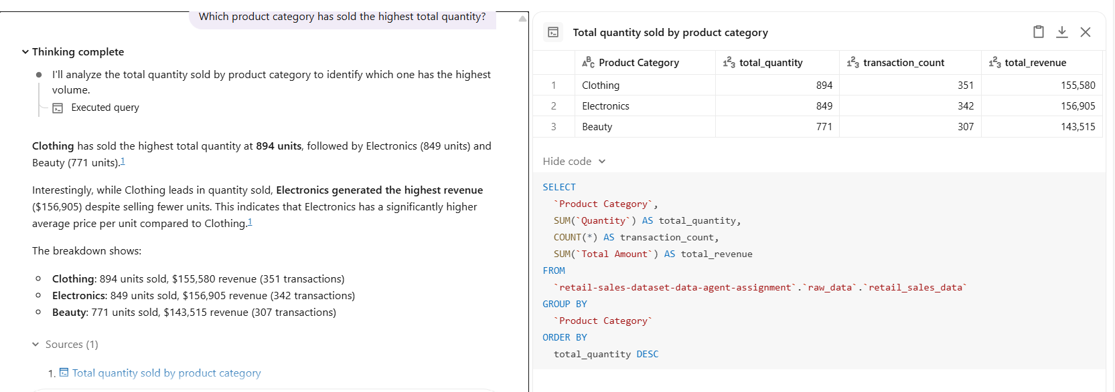

Question 8: Customer age analysis?
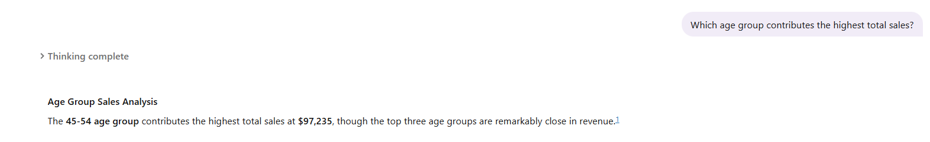
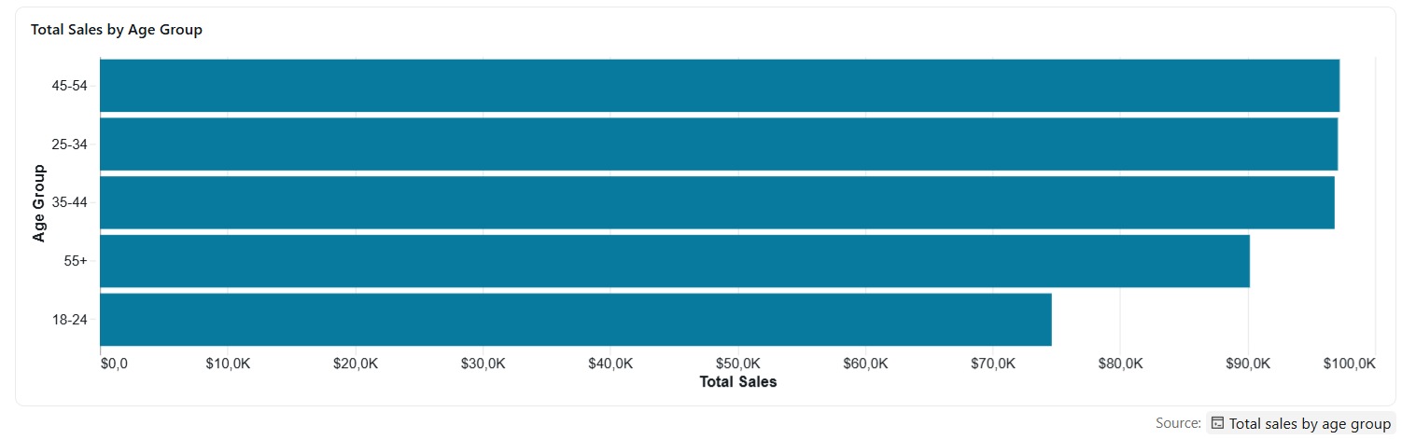
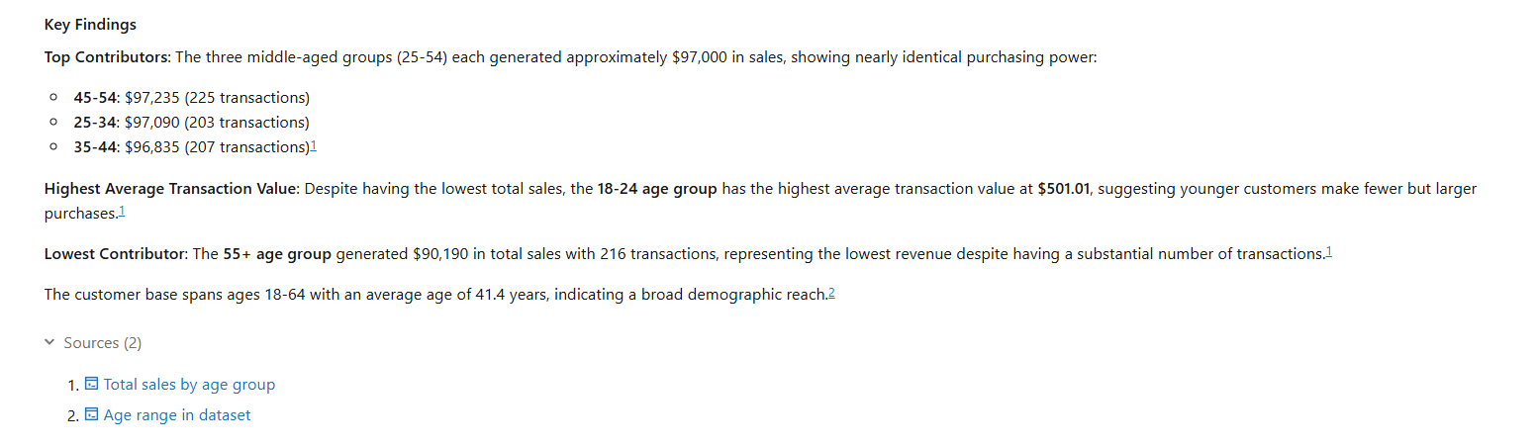
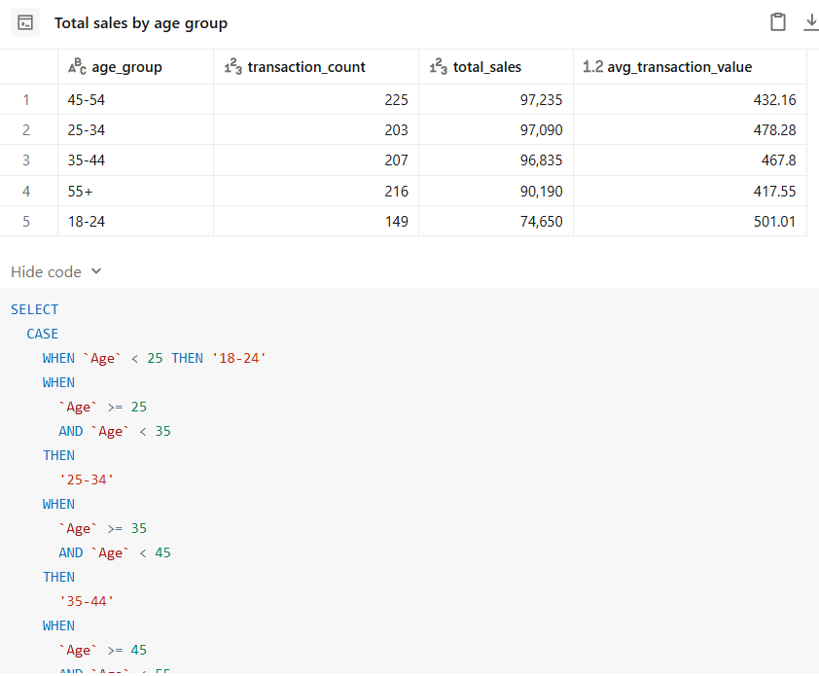
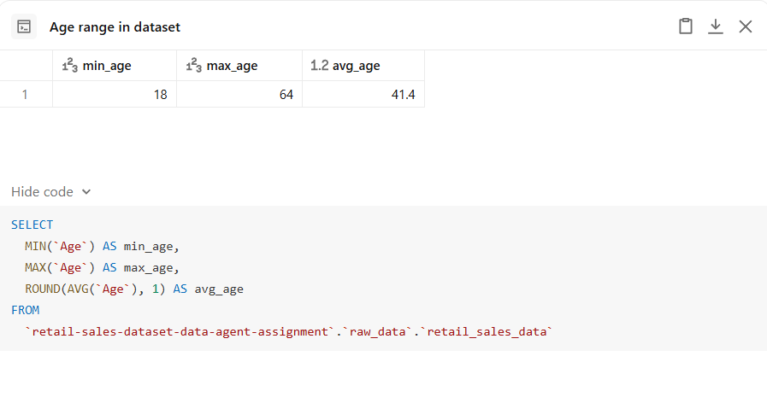

Question 9: Highest revenue month?
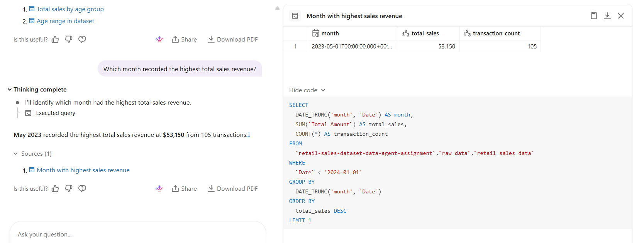
Question 10: Business insights summary.
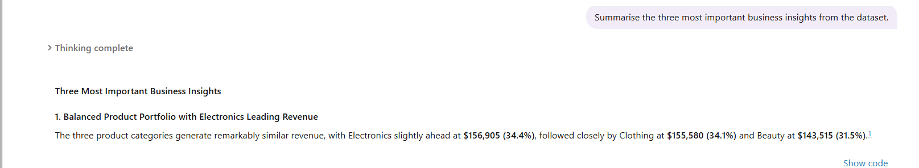
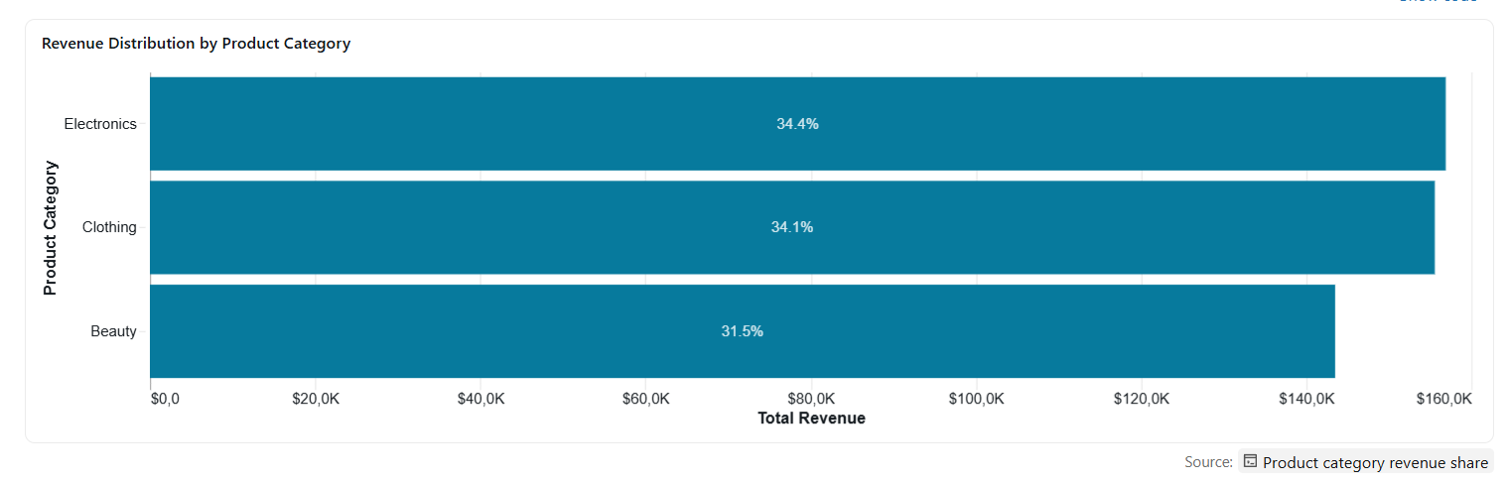
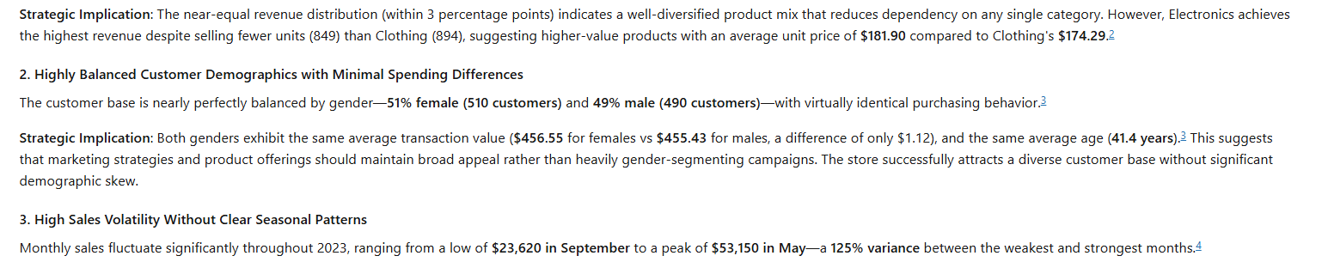
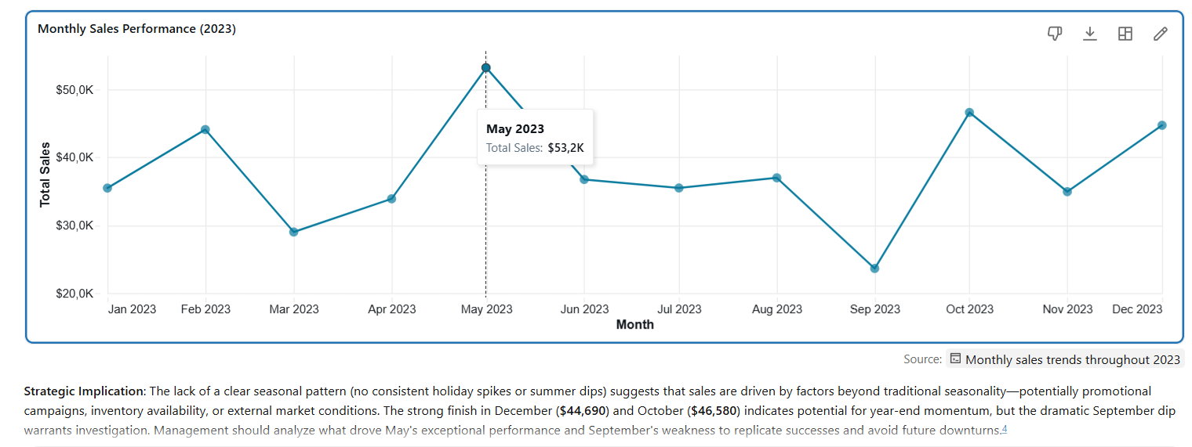

8. Validation
This presents the validation of three selected questions from the test questions to compare the Data Agent (Genie) and SQL (source). To validate if answers are correct, I have used the Aggregated SQL method where I wrote my own SQL query and compared the results for each answer given by the agent. The format will present the Business question asked, followed by the screenshot of the Genie response, then my SQL query, followed by the screenshot of the SQL result, and then a short verdict that explains whether the answer is correct, partially correct, or wrong.
Validation 1: Product Performance
Business Question
4. Which product category generated the highest total sales revenue?
Genie Response
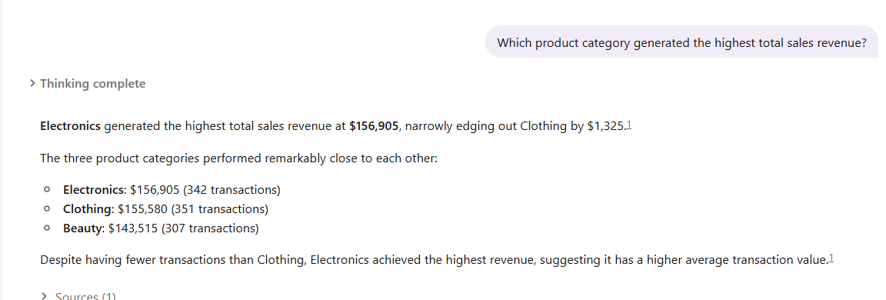
SQL Query
SELECT
`Product Category`,
SUM(`Total Amount`) AS Total_Sales
FROM `retail-sales-dataset-data-agent-assignment`.raw_data.retail_sales_data
GROUP BY `Product Category`
ORDER BY Total_Sales DESC;
SQL Result
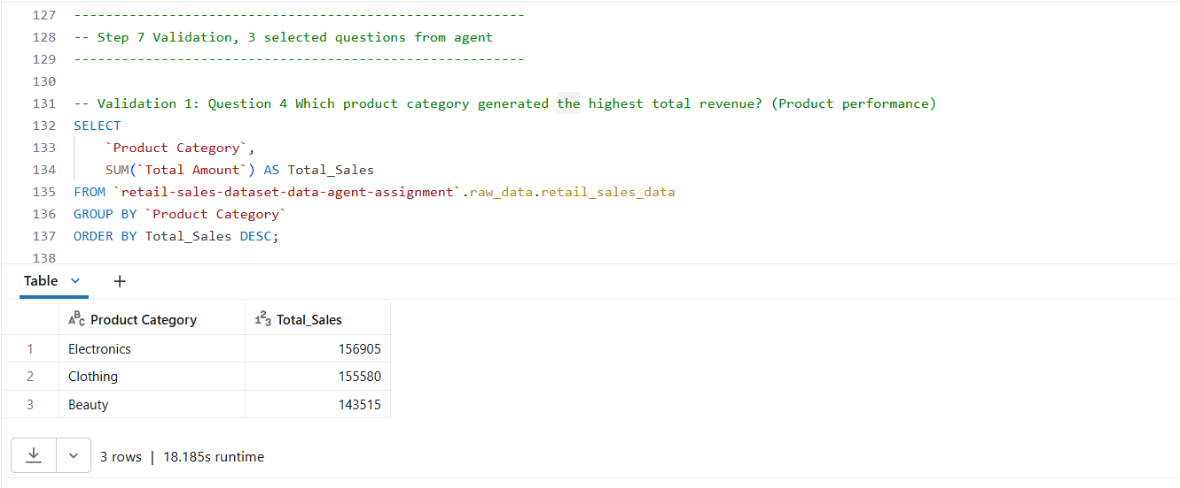
Verdict
The SQL query returned the same result as the Data Agent, with Electronics being the highest total revenue contributor at 156905, followed by Clothing and lastly Beauty. The aggregate calculation and group by return the same correct values. Therefore, the agent's response was validated and confirmed to be accurate.
About sales: This response reveals that the Electronics category contributes the highest (34.408%) to the sales revenue, even though it has fewer recorded transactions than the Clothing category (34.118%), and the Beauty category is the least in both contribution (31.472%) and transaction records. An overview of the product categories would be that they each contribute a significant amount of revenue, as they are all above 30%, despite their differences in products sold and transactions recorded.

Validation 2: Average spending by gender
Business Question
6. Compare the average transaction value for the male and female customers.
Genie Response
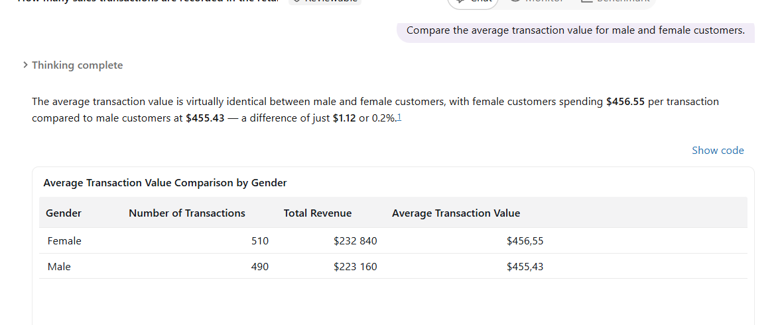
SQL Query
SELECT
Gender,
AVG(`Total Amount`) AS Ave_Transaction
FROM `retail-sales-dataset-data-agent-assignment`.raw_data.retail_sales_data
GROUP BY Gender;

SQL Result
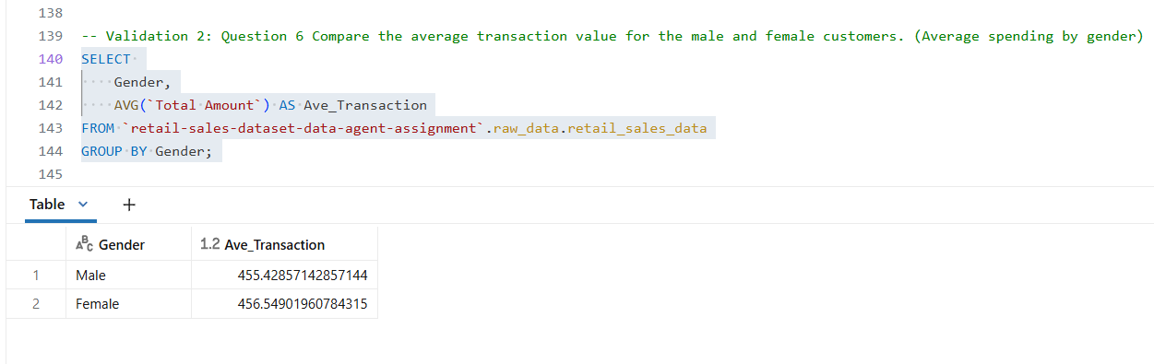
Verdict
The SQL query returned the same result as the Data Agent with female customers having a relatively higher average transaction value of 456.55 compared to male at 455.43. The Agent rounded the values to two decimal places, but the results are still accurate. The SQL query I put in was to find the average spending by gender and applying the AVG(Total Amount) was going to return an average of 456 according to my summary statistics query as seen in the screenshot below:
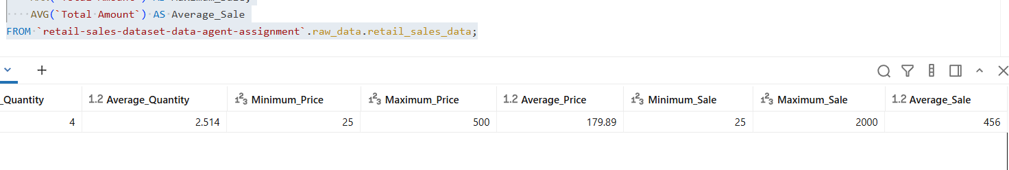
Applying the GROUP BY allows for each gender’s average spend to be compared and it gives the values of 456.55 and 455.43, whose calculated average returns the total amount average that is 456. Therefore, the agent's response was validated and confirmed to be accurate.
Average transactions by gender reveal that spending is identical between the genders; the difference is 0.2%. We could get more insight into these results by finding out the product category from which these genders purchase as products can be a customer trend factor.

Validation 3: Highest Revenue by Month
Business Question
9. Which month recorded the highest total sales revenue?
Genie Response
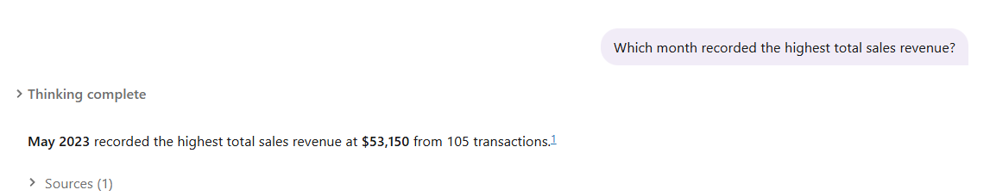
SQL Query
SELECT
MONTH(Date) AS Month,
SUM(`Total Amount`) AS Total_Sales
FROM `retail-sales-dataset-data-agent-assignment`.raw_data.retail_sales_data
GROUP BY MONTH(Date)
ORDER BY Total_Sales DESC;
SQL Result
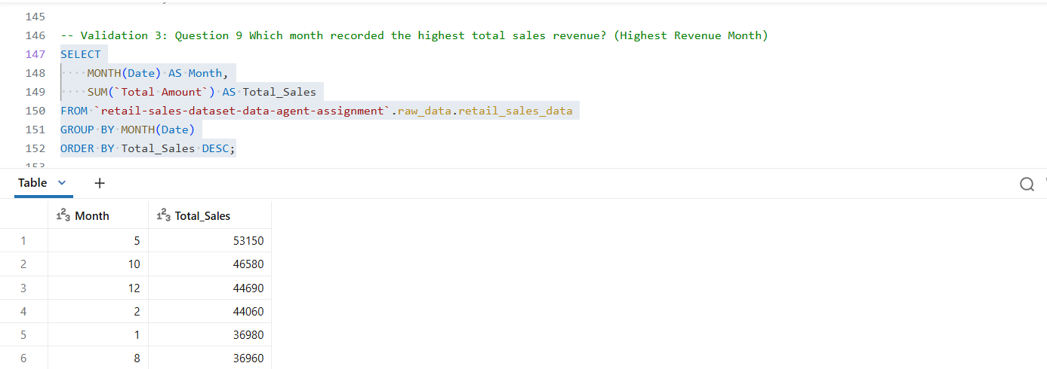

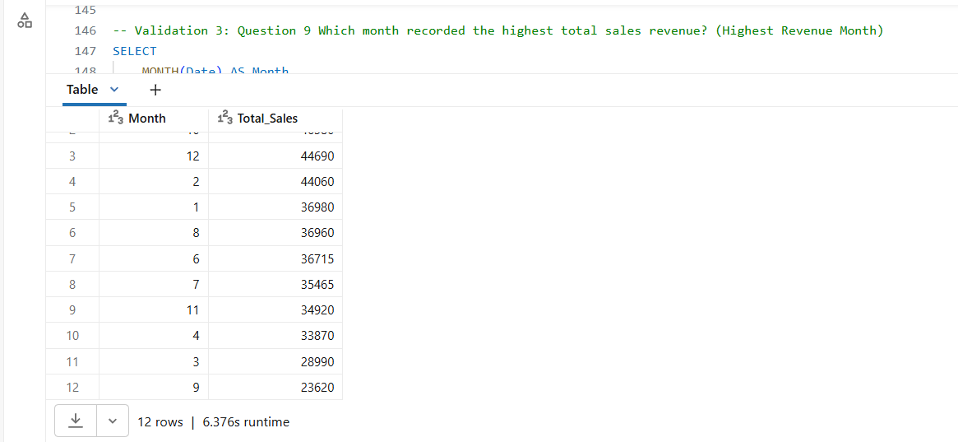

Verdict
The SQL query returned the same result as the Data Agent, with May being the highest sales revenue recorded, with a total sale of 53,150. The Genie also stated that May revenue was from 105 transactions out of 1000 transactions, that is 10.5% out of 1000 transactions over 12 months. My SQL query, through Group by and Order by functions, gives an overview of each month’s total sales revenue, and it shows that not only is the month of May the highest, but it is the outlier at 53,150, as other months are within the ranges of 23,000 to 46,580.
Therefore, the agent's response was validated and confirmed to be accurate.

9. Key Insights
This section outlines some of the findings from the project:
- The dataset contains 1,000 retail sales transactions that are not duplicated.
- Sales varied across different months, with the highest sales in the dataset in the year 2023 being the fifth month, May (53,150), followed by October (46,580), December (44,690), and then February (44,060), while the rest of the months range between 23 620 (September) and 36980 (January). This indicates fluctuations across months and gives an unclear seasonal purchase pattern; for instance, the difference between the highest sale month (May) and the lowest (September) is 29,530, and that is 55.56%.
- Balanced Product Portfolio with Electronics Leading Revenue
The Electronics category generated the highest overall revenue at 34,41% although it had fewer transaction records than the Clothing category. However, all three categories show a positive correlation, as none of them generate below 30%.
- Highly Balanced Customer Demographics with Minimal Spending Differences. Customer spending was similar between female and male customers, with an average of 456. The customer base is nearly perfectly balanced by gender—51% female (510 customers) and 49% male (490 customers)—with virtually identical purchasing behaviour.
- The Data Agent successfully answered business questions using natural language.

10. Business Recommendations
- Increase inventory for top-performing product categories.
- Investigate the reasons for lower-performing months and high-performing months to replicate the successes of the high-performing months.
- Use monthly sales trends to improve inventory planning.
- Develop targeted marketing campaigns for the highest-value customer segments, ideally the 45-54 age group, and also campaign for the currently low-value customers, that is, the 18-24 age group.

11. Conclusion
This project successfully demonstrated the development of a Retail Sales Data Agent using Databricks Genie. The project involved preparing and reviewing the dataset, configuring a custom Data Agent, testing the agent using business questions, and validating selected responses using SQL. The simplest way to validate the responses was for me through aggregated SQL, next time, I would like to learn and implement other validation methods that are more complex to guarantee accuracy. The validation process that I used confirmed that the Data Agent was capable of generating accurate insights based on the available data. This project has given me a real business data analytics experience, it also challenged and strengthened my practical skills in SQL through reviewing dataset before applying to the Genie, data preparation, insight development, and AI prompt engineering and technical documentation.

